SOCIAL IMPACT ASSESSMENT

PROPOSED BLANCO 400/132KV MTS SUBSTATION AND
DROERIVIER PROTEUS LOOP-IN LOOP-OUT POWERLINE
PROJECT

WESTERN CAPE PROVINCE

OCTOBER 2014

Prepared for

Strategic Environmental Focus (Pty) Ltd

By

Tony Barbour and Schalk van der Merwe

Tony Barbour

ENVIRONMENTAL CONSULTING AND RESEARCH

4 Oakdale Road, Newlands, 7700, South Africa

(Tel) 27-21-683 7085- (Fax) 27-21-683 7085- (Cell) 082 600 8266

(E-Mail) tbarbour@telkomsa.net

EXECUTIVE SUMMARY

INTRODUCTION AND AND LOCATION

Strategic Environmental Focus (Pty) Ltd (SEF) was appointed by Eskom Holdings SOC Limited (Eskom) as the lead consultant to manage the Environmental Impact Assessment (EIA) process for the establishment of the Blanco 400/132kv MTS substation and Droerivier Proteus loop-in loop-out power line Project. The study area is located ~ 6 km west of George in the Western Cape Province of South Africa.

Tony Barbour was appointed by SEF to undertake a specialist Social Impact Assessment (SIA) as part of the EIA process. This report contains the findings of the SIA undertaken as part of the EIA process.

DESCRIPTION OF THE PROPOSED PROJECT

The proposed project involves the establishment of a new 400/132kV Main Transmission Substation (MTS) substation with an expected development footprint of approximately 350 X 250m and loop in – loop out power lines with the Proteus - Droerivier 400kV line. The length of the loop in - loop out power lines will vary between 1.8 and 4km depending on the substation alternative option.

In terms of alternatives, seven (7) alternative site options for the proposed 400/132kV MTS were initially identified. Due to the increase in the size of the substation footprints, one of the alternatives (Original Alternative 5) has been eliminated. There are now 6 alternatives.

APPROACH TO THE STUDY

The approach to the SIA study is based on the Western Cape Department of Environmental Affairs and Development Planning Guidelines for Social Impact Assessment (February 2007). These guidelines have been endorsed by the national Department of Environmental Affairs (DEA), and are based on international best practice. The key activities in the SIA process embodied in the guidelines include:

- Describing and obtaining an understanding of the proposed intervention (type, scale, location), the communities likely to be affected and determining the need and scope of the SIA;
- Collecting baseline data on the current social environment and historical social trends;
- Identifying and collecting data on the key social issues related to the proposed development. This requires consultation with affected individuals and communities;
- Assessing and documenting the significance of social impacts associated with the proposed intervention;
- Identifying alternatives and mitigation measures.

In this regard the study involved:

- Review of socio-economic data;
- Review of relevant planning and policy frameworks for the area;
- Site specific information collected during the site visit to the area and interviews with key stakeholders;
- Review of information from similar projects;
- Identification of social issues associated with the proposed project.

SUMMARY OF KEY FINDINGS

The assessment section is divided into:

- Assessment of compatibility with relevant policy and planning context (“planning fit”);
- Assessment of social issues associated with the construction phase;
- Assessment of social issues associated with the operational phase;
- Assessment of the “no development” alternative;
- Assessment of cumulative impacts.

POLICY AND PLANNING ISSUES

The review of the relevant planning and policy documents was undertaken as a part of the SIA. The key documents reviewed included:

- Western Cape Spatial Development Framework (PSDF) (2009);
- George Municipality Draft 2012-2017 Integrated Development Plan (2012);
- George Municipality Spatial Development Framework (2013);
- Draft Blanco Structure Plan (2009).

With reference to the proposed project the siting of power lines is addressed under Objective 5 of the Provincial Spatial Development Framework. Objective 5: Conserve the sense of place of important landscapes, of the Provincial spatial Development Framework, highlights the importance of tourism to the Provincial economy. The PSDF also stipulates that, with regard to the siting and design of future power lines and other visibly substantial infrastructural development, the relevant provincial guidelines should be followed, and proposals should include provision for environmental, visual and heritage impact assessments. The PSDF notes that the shortest-distance approach to the alignment of transmission lines raises issues of visual blight, unviable shaped land parcels, need for access roads and destruction of cultural landscapes.

The following policy directive is applicable:

HR26 (…) transmission lines (…) should be aligned along existing and proposed transport corridors rather than along point to point cross-country routes. (Mandatory directive)

The George SDF notes that productive agricultural areas should be protected and scenic landscapes and features safeguarded.

Based on the findings of the review Alternative 5 is the most compatible option in terms of the meeting the land use planning and policy documents that have a bearing on the identification of a suitable site alternative.

CONSTRUCTION PHASE

The key social issues associated with the construction phase include:

Potential positive impacts
- Creation of employment opportunities

The construction related activities will create temporary employment opportunities which, in turn will create an opportunity for local George economy. The creation of employment opportunities will be the same for each of the seven alternatives. The significance rating of Medium Positive therefore applies to each of the seven alternatives and does not influence the identification of most suitable site alternative.

Potential negative impacts
- Impacts associated with the presence of construction workers on site
- Impact on farming operations;
- Impacts associated with movement of heavy vehicles during the construction phase.

The most significant negative social issue during the construction phase is linked to the loss of productive farmland and the disturbance to farming activities by construction related activities, specifically activities associated with the establishment of the power line routes. The establishment of the substations would result in a permanent loss of land. In the case of Alternative 1-4 and 6 the land affected is productive farmland. The power line routes for Alternative 1-4 and 6 also traverse productive farm lands. The construction related activities associated with establishing the power lines include loss of productive farmland, damage to farmland by construction vehicles, disruption of farming related activities, such as planting and grazing, and damage to farm infrastructure, such as irrigation lines, fences and gates. Alternative 6 is located in an area that was previously planted with alien trees (plantation area). Due to its location the agricultural potential of this area is lower than the areas affected by the other alternative substation sites. The power lines associated with Alternative 5 are located within a cleared servitude for an existing power line route within a forestry area. The impacts on farming operations associated with Alternative 1-4 and 6 will therefore be greater than the impacts associated with Alternative 5.

Table 1 summarises the significance of the impacts associated with the construction phase.

Table 1: Summary of social impacts during construction phase

Impact | Significance  No Mitigation | Significance  With Enhancement /Mitigation
Creation of employment and business opportunities (Alternative 1-6) | Medium  (Positive impact) | Medium  (Positive impact)
Presence of construction workers and potential impacts on family structures and social networks  (Alternative 1-6) | Low  (Negative impact for community as a whole)  Medium-High  (Negative impact of individuals) | Low  (Negative impact for community as a whole)  Medium-High  (Negative impact of individuals)
Impact on farming operations  - Alternative 1-4 and 6  - Alternative 5 | Medium  (Negative impact)  Low  (Negative) | Medium  (Negative impact)  Low  (Negative)
Impacts associated with construction vehicles  (Alternative 1-6) | Low  (Negative impact) | Low  (Negative impact)

OPERATIONAL PHASE

The key social issues associated with the operational phase include:

Potential positive impacts
- Provision of energy infrastructure

Eskom have indicated that there is a need to up-grade the existing power supply and distribution network in the area in order to meet the energy needs associated with future economic growth and development in the Southern Cape region. Each of the Alternatives (1-6) meets the technical requirements to accommodate the future energy need for the Southern Cape region. However, Alternative 5 is the preferred alternative.

Potential negative impacts
- Impact on farming operations;
- Impact on tourism activities;
- Impact on sense of place and character of the area.

Impact on farming operations
The establishment of the substations would result in a permanent loss of land. In the case of Alternative 1-4 and 6 the land affected is productive farm land. In terms of the power line routes, the power line routes for Alternative 1-4 and 6 all traverse productive farm lands. The landowners that stand to be most impacted are the ones on whose property the proposed substations are located. These are Nelius van Greunen (Alternative 1, 2, 3 and 6), Plattner Estates (Alternative 4) and Power Construction (Alternative 3).

The findings of the SIA also indicate that the presence of existing power lines appears to impact on the productivity of dairy cows. As a result grazing time under the power lines is limited and cows have to be moved on a regular basis. As a result land under and within the vicinity of the power lines is not fully utilised. This represents a loss of potential agricultural land.

Maintenance of power lines also impacts on farming operations. The contractors require access to the power line servitude. Depending on the timing of the maintenance this can impact on farming activities located in the vicinity of the power lines. The movement of maintenance vehicles can also damage farmland and farm infrastructure, such as fences, gates and irrigation equipment. Maintenance workers not familiar with or respectful of farming activities can also forget to close farm gates. The impacts on farming activities are therefore not only associated with the loss of land directly affected by the substation and the power line towers, but impacts are also associated with impact on productivity of dairy herds, loss of productive land and activities associated with maintenance. All of the landowners in the area affected by Alternative 1-4 and 6 are likely to experience such impacts.

Alternative 5 is located in an area that was previously planted with alien trees (plantation area). Due to its location the agricultural potential of this area is lower than the areas affected by the other alternative substation sites (Alternative 1-4 and 6). The power line associated with Alternative 5 also does not cut across established farmland. The impacts on farming operations associated with Alternative 1-4 and 6 will therefore be greater than the impacts associated with Alternative 5.

Impact on tourism
The Geelhoutboom area is identified as tourist area and forms part of the Hops Route. The area also contains a number of farm based B&Bs and is popular area for mountain biking. In terms of the proposed project the properties that stand to be most negatively affected include Uitsig Farm, Groenewiede and Arendsrus.

Uitsig Farm is an established wedding and event venue that caters for a maximum of 130 guests and includes a guest house that can accommodate 10 people. The selling points are the views and the rural setting. In addition, the facility is located within 6 km of George and the George Airport. The facility is therefore accessible and there is adequate accommodation within 6 km of the venue. The power lines associated with Alternative 3 and 6 are located within 30 m of the wedding venue and facilities on Uitsig Farm. The visual impacts associated with the power lines would have a significant negative impact on the qualities that make Uitsig and attractive and sought after wedding and event venue. Based on the findings of the SIA these impacts would, in all likelihood, severely compromise the future viability of the venue. In addition, the impact on the owners of the facility this would also impact on the guest houses in the area that provide accommodation for guests.

Groeneweide Farm (Portion 7 of Farm 217) is located immediately to the north of Uitsig Farm. The activities on the farm include propagation of strawberries for the export market and a guest house, which accommodates 10 people. The existing Proteus - Droerivier 400kV power line traverses the southern section of the farm near the entrance and also forms the eastern boundary of the property. The power lines associated with Alternative 3 and 6 would add to the impacts already associated with the existing power lines, which in turn, would impact negatively on the farms sense of place and its potential as tourist destination.

Arendsrus is located in the foothills of the Outeniqua Mountains, to the north of the Nico van Rensburgs Farm (Portion 61 of Geelhoutboom 217). Access to the guest house is via a gravel road that runs past the van Rensburg’s dairy. The power line routes for Alternative 2 and 4 are located adjacent to this road and will have a negative visual impact on visitors to the facility. The power lines associated with Alternative 1 are also likely to have a negative visual impact for visitors to the area.

Impact on sense of place
The impact on the areas sense of place associated with Alternative 1-4 and 6 will be greater that the impact associated with Alternative 5.

The reasons for this are linked to:

- The proximity of Alternative 1-4 and 6 (substation and power lines) in relation to existing farm houses in the area. The power lines associated with Alternative 1-4 and 6 all pass within 50 m of at least one farmstead. The affected property owner’s sense of place will therefore be significantly affected;
- The proximity of the Alternative 1-4 and 6 (substations) in relation to the Geelhoutboom Road and visibility to passing motorists. The substation sites for Alternative 1, 2 and 6 are all located within 300 m of the Geelhoutboom Road. The substation sites for Alternative 3 and 4 are located ~ 1 and 1.5 km from the road respectively and are likely to be less visible;
- The power lines associated with Alternative 1-4 and 6 all cross public roads (Geelhoutboom Road and road that provides access to Uitsig and Groeneweide). The power lines will therefore be visible to motorists using these roads.

In the case of Alternative 5, the substation site is located on the lower slopes of the Outeniqua Mountains in an area that was previously under plantation. The substation site is located ~ 4-5 km north of the Geelhoutboom Road and is unlikely to be visible to passing motorists. The substation will be visible from the houses associated with the forestry station located to the north of the site. The power lines associated with Alternative 6 follow an existing power line servitude that runs in an east-west direction through forestry plantations on the lower slopes of the Outeniqua Mountains. The existing power line is not highly visible and does not impact on private landowners. The potential impact on the areas sense of place will therefore be lower due to the location of the substation and power line route associated with Alternative 5.

The significance of the impacts associated with the operational phase are summarised in Table 2.
Table 2: Summary of social impacts during operational phase

Impact | Significance  No Mitigation | With Enhancement /Mitigation
Provision of energy infrastructure | Medium  (Positive impact) | Medium  (Positive impact)
Impact on farming operations  - Alternative 1-4 and 6  - Alternative 5 | Medium  (Negative impact)  Low  (Negative) | Medium  (Negative impact)  Low  (Negative)
Impact on tourism  - Alternative 1-4 and 6  - Alternative 5 | High  (Negative impact)  Low  (Negative) | Low  (Negative impact)  Low  (Negative)
Impact on sense of place  - Alternative 1-4 and 6  - Alternative 5 | High  (Negative impact)  Low  (Negative) | Low  (Negative impact)  Low  (Negative)

Cumulative impacts

The cumulative impact on the areas sense of place associated with Alternative 1-4 and 6 will be concentrated in relatively small area, namely the a valley that is approximately 1.5-2 km wide to the north of the Geelhoutboom Road, which then widens out to the south of the road. This area has already been heavily impacted by the existing Blanco substation and associated power lines, including the Proteus - Droerivier 400kV line. The establishment of a new MTS and the associated power lines would result in a negative cumulative impact on an area that has already been negatively impacted. This is not regarded as equitable and further prejudices the landowners in the area who have already been negatively impacted.

In the case of Alternative 5, the cumulative impacts are likely to be considerably lower. Due to the location the substation site and associated with power lines will not impact on the area that has already been impacted by the Blanco substation. Likewise the substation and power lines will not be visible to motorists driving along the Geelhoutboom Road.

No-development option

The No-Development option would maintain the existing situation. Eskom have however indicated that there is a need to up-grade the existing power supply and distribution network in the area in order to meet the energy needs associated with future economic growth and development in the Southern Cape region. The No-Development Option is therefore not a viable alternative and would have a negative impact on the future development of the region.

CONCLUSIONS AND RECOMMENDATIONS

The findings of the SIA indicate that there is a need to up-grade the existing power supply and distribution network in the area in order to meet the energy needs associated with future economic growth and development in the Southern Cape region.

The findings of the SIA also indicate that Alternative 1-5 and 7 will all result in significant social impacts during both the construction and operational phase. Alternative 1-4 and 6 will also result in a negative cumulative impact on an area that has already been negatively impacted by power lines. This is not regarded as equitable and further prejudices the landowners in the area who have already been negatively impacted. None of these alternatives is therefore supported by the findings of the SIA. In terms of alternatives, Alternative 5 is the preferred alternative.

IMPACT STATEMENT

Alternative 1-4 and 6 will all result in significant social impacts. None of these alternatives is therefore supported by the findings of the SIA. Alternative 5 is therefore the preferred alternative.

TABLE OF CONTENTS

EXECUTIVE SUMMARY i
SECTION 1: INTRODUCTION 1
1.1 INTRODUCTION 1
1.2 TERMS OF REFERENCE 3
1.3 PROJECT DESCRIPTION 3
1.4 OVERVIEW OF THE STUDY AREA 6
1.5 PPROACH TO STUDY 17
1.5.1 Definition of social impacts 18
1.5.2 Timing of social impacts 19
1.6 ASSUMPTIONS AND LIMITATIONS 19
1.6.1 Assumptions 19
1.6.2 Limitations 19
1.7 SPECIALIST DETAILS 20
1.8 DECLARATION OF INDEPENDENCE 20
1.9 REPORT STUCTURE 20
SECTION 2: POLICY AND PLANNING ENVIRONMENT 21
2.1 INTRODUCTION 21
2.2 Western Cape Spatial Development Framework (2009) 21
2.3 George Municipality Draft 2012-2017 IDP 22
2.4 George Municipality Spatial Development Framework (2013) 23
2.5 Draft Blanco Structure Plan (2009) 25
SECTION 3: OVERVIEW OF STUDY AREA 26
3.1 INTRODUCTION 26
3.2 ADMINSTRATIVE CONTEXT 26
3.3 LOCAL COMMUNITIES 27
3.3.1 George 27
3.3.2 Blanco 28
3.3.3 Rural area west of George 29
3.4 DEMOGRAPHIC PROFILE 29
3.1.1 Demographic information 29
3.1.2 Access to municipal services 32
3.5 ECONOMIC OVERVIEW 33
3.5.1 Tourism 34
SECTION 4: ASSESSMENT OF KEY SOCIAL ISSUES 36
4.1 INTRODUCTION 36
4.2 IDENTIFICATION OF KEY SOCIAL ISSUES 36
4.3 POLICY AND PLANNING ISSUES 36
4.4 SOCIAL IMPACTS ASSOCIATED WITH THE CONSTRUCTION PHASE 37
4.4.1 Creation of employment opportunities 38
4.4.2 Presence of construction workers in the area 39
4.4.3 Impacts associated with construction vehicles 41
4.5 SOCIAL IMPACTS ASSOCIATED WITH OPERATIONAL PHASE 43
4.5.1 Provision of energy infrastructure 43
4.5.2 Impact on farming operations 44
4.5.3 Impact on tourism and tourist related facilities 48
4.5.4 Impact on sense of place 50
4.6 CUMULATIVE IMPACTS 52
4.7 ASSESSMENT OF NO-DEVELOPMENT OPTION 55
SECTION 5: KEY FINDINGS AND RECOMMENDATIONS 56
5.1 iNTRODUCTION 56
5.2 SUMMARY OF KEY FINDINGS 56
5.2.1 Policy and planning issues 56
5.2.2 Construction phase 57
5.2.3 Operational phase 58
5.2.4 Assessment of cumulative impacts 61
5.2.5 Assessment of no-development option 61
5.3 CONCLUSIONS AND recommendations 62
5.4 IMPACT STATEMENT 62
ANNEXURE A 63
ANNEXURE B: ASSESSMENT METHODOLOGY 64

ACRONYMS

DEA Department of Environmental Affairs (National)
DEA&DP Department of Environmental Affairs and Development Planning (WCP)
DM District Municipality
HD Historically Disadvantaged
EIA Environmental Impact Assessment
GLM George Local Municipality
IDP Integrated Development Plan
LED Local Economic Development
LM Local Municipality
PGDS Provincial Growth and Development Strategy
PSDF Provincial Spatial Development Framework
SDF Spatial Development Framework
SIA Social Impact Assessment
WCP Western Cape Province

SECTION 1: INTRODUCTION

INTRODUCTION

Strategic Environmental Focus (Pty) Ltd (SEF) was appointed by Eskom Holdings SOC Limited (Eskom) as the lead consultant to manage the Environmental Impact Assessment (EIA) process for the establishment of the Blanco 400/132kv MTS substation and Droerivier Proteus loop-in loop-out power line Project. The study area is located ~ 6 km west of George in the Western Cape Province of South Africa.

Tony Barbour was appointed by SEF to undertake a specialist Social Impact Assessment (SIA) as part of the EIA process. This report contains the findings of the SIA undertaken as part of the EIA process.

In terms of alternatives, seven (7) alternative site options for the proposed 400/132kV MTS were initially identified. Due to the increase in the size of the substation footprints, one of the alternatives (Original Alternative 5) has been eliminated. There are now 6 alternatives as opposed to 7 (Figure 1.1). In addition the power line alignments for Alternative 2 (same substation location as Original) and 6 (Original Alterative 7) have also been modified slightly.

In terms of the revised list of 6 Alternatives, Alternative 1-4 are the same as the initial list of Alternatives. The initial Alternative 5 has been dropped. The revised Alternative 5 corresponds to initial Alternative 6, and revised Alternative 6 corresponds to initial Alternative 7. Table 1.1 provides a list of the original 7 Alternatives compared to the revised list of 6 Alternatives. Figure 1.2 indicates the location of the original seven alternatives.

Table 1.1: List of 7 Alternatives compared to revised list of 6 Alternatives

Original Alternatives (7) | Revised Alternatives (6)
Alternative 1 | Revised Alternative 1 corresponds to original Alternative 1
Alternative 2 | Revised Alternative 2 corresponds to original Alternative 2
Alternative 3 | Revised Alternative 3 corresponds to original Alternative 3
Alternative 4 | Revised Alternative 4 corresponds to original Alternative 4
Alternative 5 | The Original Alternative 5 has been dropped due to size constraints required for the sub-station footprint
Alternative 6 | Revised Alternative 5 corresponds to original Alternative 6
Alternative 7 | Revised Alternative 6 corresponds to original Alternative 7

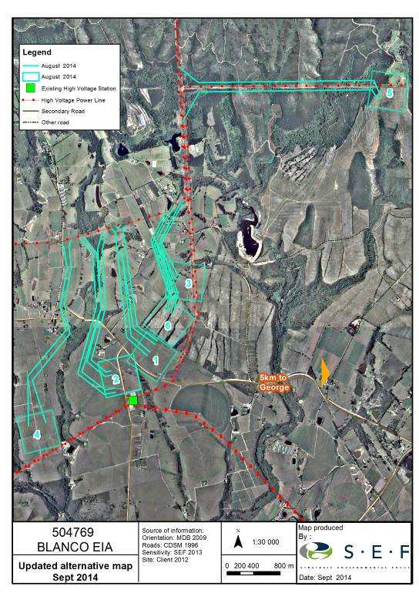

Figure 1.1: Location of revised Alternatives 1-6 associated with the Blanco 400/132kv MTS substation and Droerivier Proteus loop-in loop-out power line Project

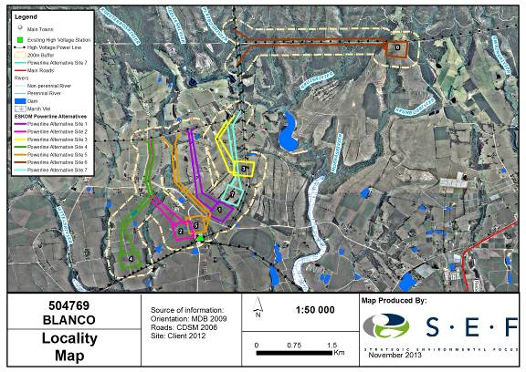

Figure 1.2: Location of the original seven alternatives associated with the proposed Blanco 400/132kv MTS substation and Droerivier Proteus loop-in loop-out power line Project

TERMS OF REFERENCE

The terms of reference for the SIA require:

- A description of the environment that may be affected by the activity and the manner in which the environment may be affected by the proposed facility.
- A description and assessment of the potential social issues associated with the proposed facility.
- Identification of enhancement and mitigation aimed at maximizing opportunities and avoiding and or reducing negative impacts.

PROJECT DESCRIPTION

The proposed Blanco substation and line project is located within the Blanco area approximately 5 km west of the outskirts of the town of George in the Western Cape Province.

The proposed project involves the establishment of a new 400/132kV Main Transmission Substation (MTS) substation with an expected development footprint of approximately 350 X 250m and loop in – loop out power lines with the Proteus - Droerivier 400kV line. The length of the loop in - loop out power lines will vary between 1.8 and 4km depending on the substation alternative option. The 400kV power lines each have a 55 m wide or 110m for 2 lines. The type of tower structure proposed for the 400kV loop in – loop out power lines will be from the 515 series (Heavy) Self - Supporting Suspension Tower (developed by Eskom in 1983), which will support quad (X4) wolf conductors in conjunction with 120KN glass insulators. The spacing between the sub-conductors is estimated at 380mm and the mid-span ground clearance of this tower (in order to achieve optimal electrical performance) is approximately 9.1m (SEF, Final Scoping Report, August, 2013).

Seven (7) alternative site options for the proposed 400/132kV MTS were initially identified (Figure 1.2). The initial scope identified four (4) alternatives sites. However based on input from the affected landowners three (3) additional alternatives were identified. Due to the increase in the size of the substation footprints, one of the alternatives (Original Alternative 5) has been eliminated. There are now 6 alternatives as opposed to 7 (Figure 1.1). In addition the power line alignments for Alternative 2 (same substation location as Original) and 6 (Original Alterative 7) have also been modified slightly.

In terms of the revised list of 6 Alternatives, Alternative 1-4 are the same as the original list of Alternatives. The original Alternative 5 has been dropped. The revised Alternative 5 corresponds to original Alternative 6, and revised Alternative 6 corresponds to original Alternative 7 (See Table 1.1). The new substation will be linked to the Droerivier Proteus 400kV via a loop in – loop out power line. The six alternatives and associated loop-in/loop out power line routes are described below. The location of the six alternative MTS sites and associated loop in – loop out power line alignments are illustrated in Figure 1.1.

Alternative Substation Site 1
Alternative 1 is located to the north of the Geelhoutboom Road, ~ 500 m north of the existing 132kV Blanco substation. In site is located on agricultural land and will impact on a centre pivot. Eskom have indicated that Alternative 1 is the technically preferred location due the ease with which it can be integrated into the existing network.

Power line route
The power line route associated with Alternative 1 is ~ 2.5km in length and runs in north westerly direction for ~ 400 m before swinging north and linking up with the Droerivier Proteus 400kV line. The proposed route crosses the access road to a number of properties that are located to the north of the proposed substation site, including Uitsig and Groeneweide. The power line route also cuts across agricultural land.

Alternative Substation Site 2
Alternative 2 is located ~ 300 m west of the existing 132 kV Blanco substation. A residential dwelling and irrigated agricultural land will be affected by this alternative. In addition, there is also a distribution line coming into the existing 132kV substation.

Power line route
The power line route is ~ 2.9km in length and runs in north-westerly direction for approximately 1.2 km before swinging north and linking up with the Droerivier Proteus 400kV line. The proposed route runs across agricultural land and also crosses a perennial river and a Geelhoutboom Road. A number of dwellings are located in close proximity of the proposed power line. The route also runs parallel to the access road to Arendsrus Guest Farm which runs along a ridge that forms the western boundary of the north – south trending valley.

Alternative Substation Site 3
Alternative 3 is located ~ 1.8 km to the north-east of the existing substation. Alternative 3 is closer to the Droerivier Proteus 400kV line than the other alternatives. The alternative may affect the existing distribution line passing through the site.

Power line route
The power line route is ~ 1.7km in length and runs in northerly direction from Alternative 3 to the Droerivier Proteus 400kV line. The proposed route runs cuts across the entrance to Farm Uitsig which is used for weddings and other functions. The route also traverses agricultural land and the access road to Farm Uitsig and Groeneweide.

Alternative Substation Site 4
Alternative 4 is located ~ 1.2 km to the south west side of the existing 132 kV Blanco substation. Due to the location the loop in loop-out line with the Droerivier Proteus 400kV will be longer. The proposed site is located on a horse stud farm.

Power line route
The power line route is ~ 3.7km in length and runs in northerly direction for ~ 1 km before swinging north east for ~ 1 km and then north and linking up with the Droerivier Proteus 400kV. The final section of the alignment is shared with the alignment for Alternative 2. The proposed route runs across agricultural land and also crosses a perennial river and the Geelhoutboom Road. As in the case with Alternative 2, a number of dwellings are located in close proximity of the proposed power line. The route also runs parallel to the access road to Arendsrus Guest Farm which runs along a ridge that forms the western boundary of the north – south trending valley. .

Alternative Substation Site 5
Alternative 5 is located in foothills of the Outeniqua Mountains, ~ 4.5 km north east of the existing 132 kV Blanco substation. A small forestry station, including a number of dwellings, is located immediately to the north of the proposed site.

Power line route
The power line route is ~ 4.1km in length and runs in easterly direction from Alternative 5 to the Droerivier Proteus 400kV. The proposed route follows the alignment of an existing power line that runs along the foothills of the Outentiqua Mountains. The land is owned by the Department of Forestry.

Alternative Substation Site 6
Alternative 6 is located ~ 1.0 km to the north-east of the existing substation on land that was recently covered with forest plantation.

Power line route
The power line route is ~ 1.7km in length and runs in northerly direction from Alternative 6 to the Droerivier Proteus 400kV line along the same alignment as the power line route as Alternative 3. The proposed route runs cuts across the entrance to Farm Uitsig which is used for weddings and other functions. The route also traverses agricultural land and the access road to Farm Uitsig and Groeneweide.

OVERVIEW OF THE STUDY AREA

The proposed project area is located in the Geelhoutboom area, ~ 5-6 km west of the town of George. The area is located in the foothills of the Outeniqua Mountains which are located to the north. The area is a well-established agricultural area with high potential agricultural land. The average rainfall in the area is between 800 and 1000 mm per annum making the area a sought after agricultural area. The main agricultural activities in the area include dairy and beef farming, maize and vegetable farming.

The proposed substation sites associated with Alternative 1, 2, 4 and 6 are located in a relatively flat area located to the south of the foothills of the Outeniqua Mountains. The area is cut by a number of perennial streams flowing out of the Outeniqua Mountains in the north towards the Indian Ocean to the south and south west. The areas between the perennial rivers are intensively farmed. The existing Droerivier-Proteus 400kV line runs in an east – west direction along the foothills of the Outeniqua Mountains and links up with a line that crosses the mountains and links up with the 132 kV Blanco substation (Photograph 1.1 and 1.2). The Blanco substation is located ~ 1 km south of the Geelhoutboom Road. With the exception of Alternative 3 and 6, all of the loop in–loop out power line routes runs along a north – south trending valley, which starts on the lower slopes of the Outeniqua Mountains and runs in a north – south direction. The Geelhoutboom Road cuts across the southern end of the valley. The valley is ~ 1.5-2 km wide is bisected by the existing Droerivier Proteus 400kV line.

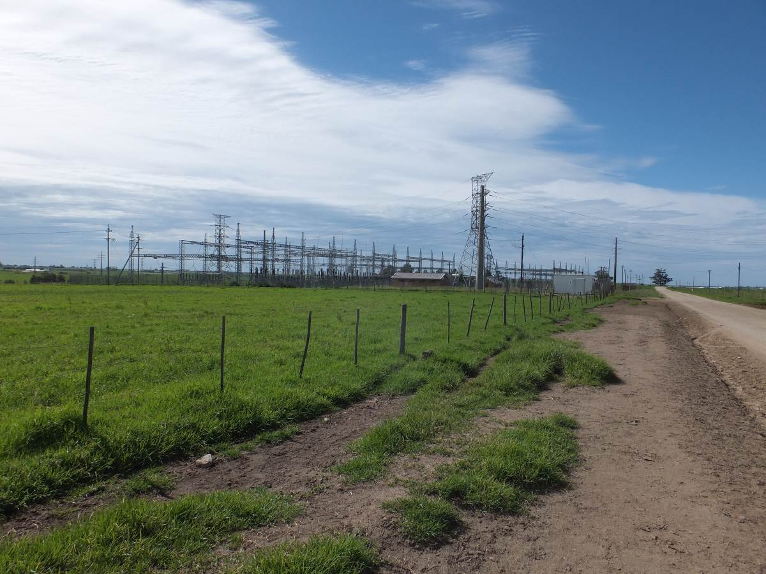

Photograph 1.1: Existing Blanco substation

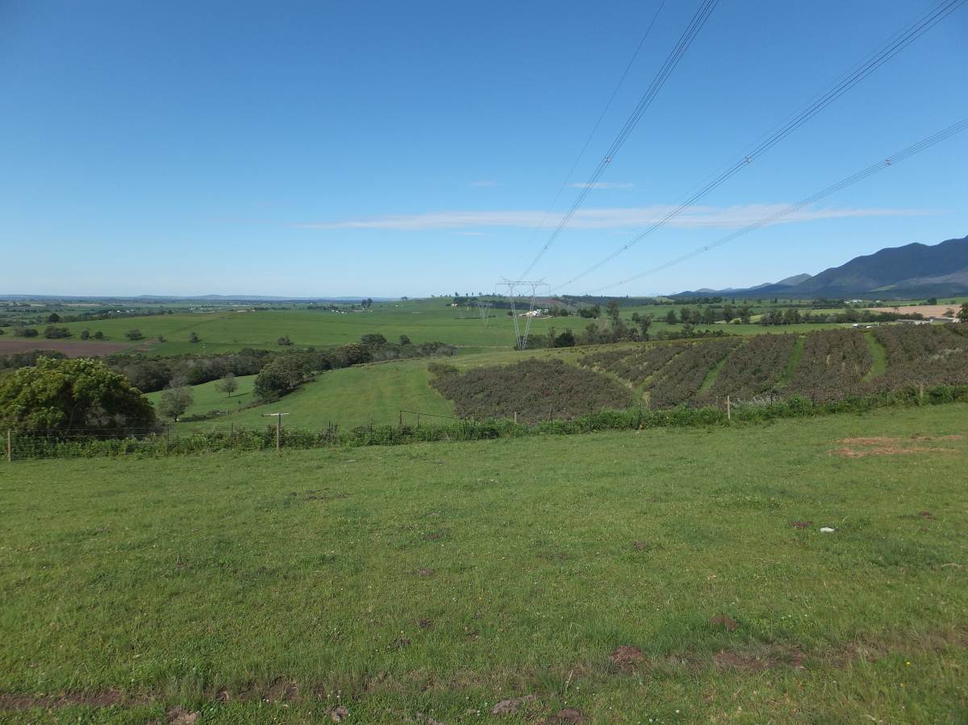

Photograph 1.2: View looking south west along existing Droerivier-Proteus 400kV power line

Alternative Substation Site 1
The substation site associated with Alternative 1 is located on an area that is irrigated by a centre pivot ~ 200 m the north of the Geelhoutboom Road. The substation will be clearly visible from the Geelhoutboom Road (Photograph 1.3). The property is owned van Greunen Boerdery CC. The power line route is ~ 2.5km in length and cuts across established agricultural land, including an area that is irrigated by a centre pivot on Portion 45 and 47 of Farm Geelhoutboom 217 owned by Jurgens Botha and his father (Photograph 1.4 and 1.5). The corridor also passes directly over Jurgen Botha’s house. The final 500-700 m northerly section of the power line is located 300 m west of the residence of Allan Armstrong. This section of the line will be highly visible from the house.

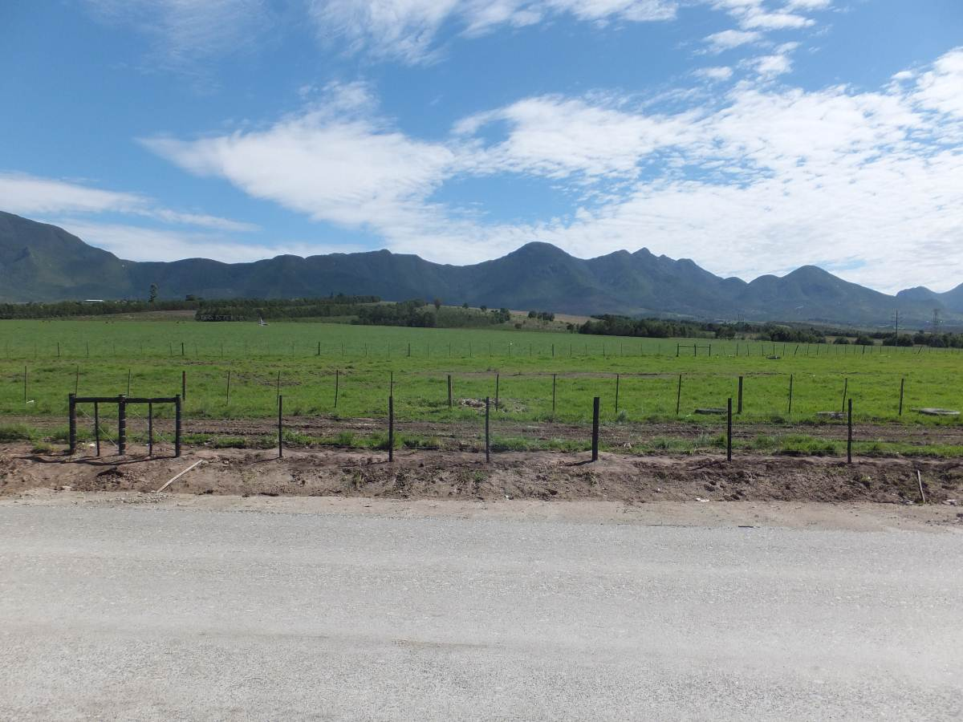

Photograph 1.3: View from Geelhoutboom Road looking north towards location of substation Alternative 1, 6 and 3

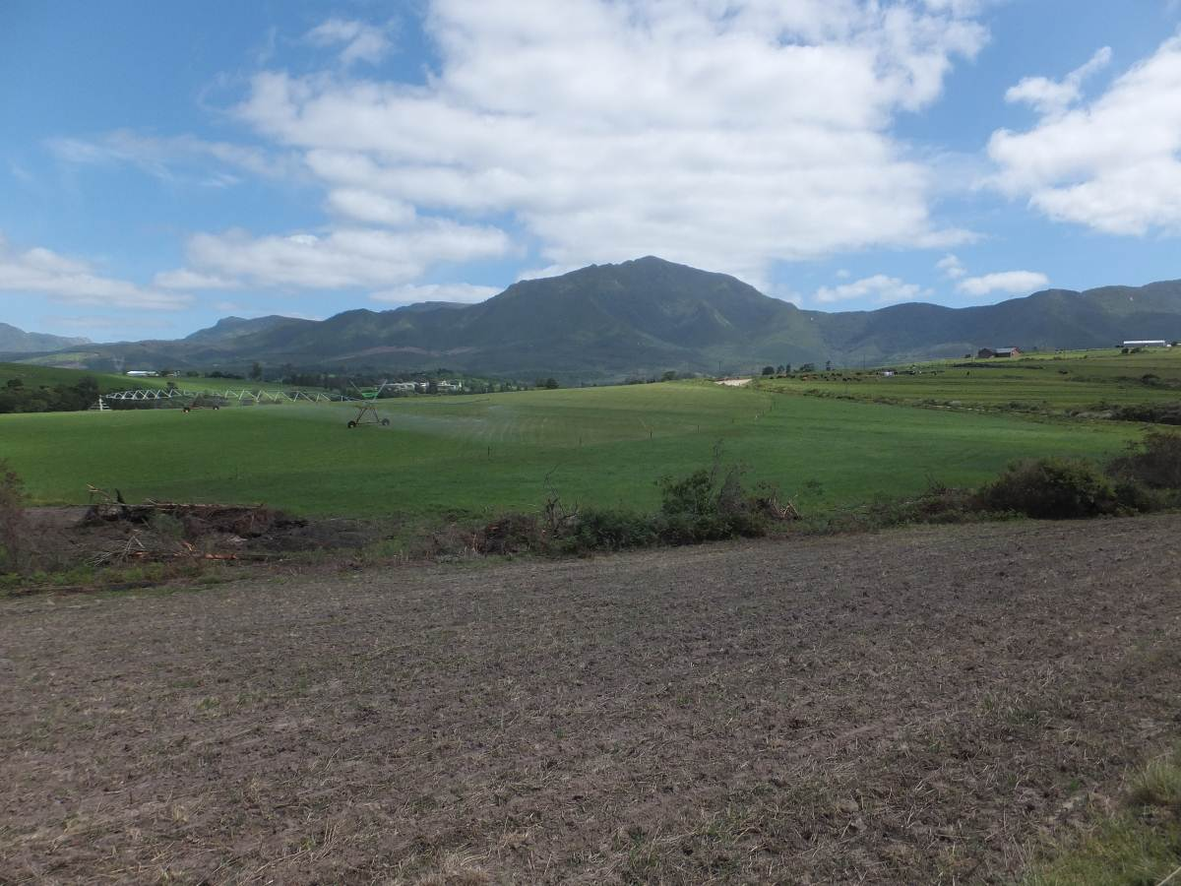

Photograph 1.4: View looking north-west along alignment of power line route for substation Alternative 1

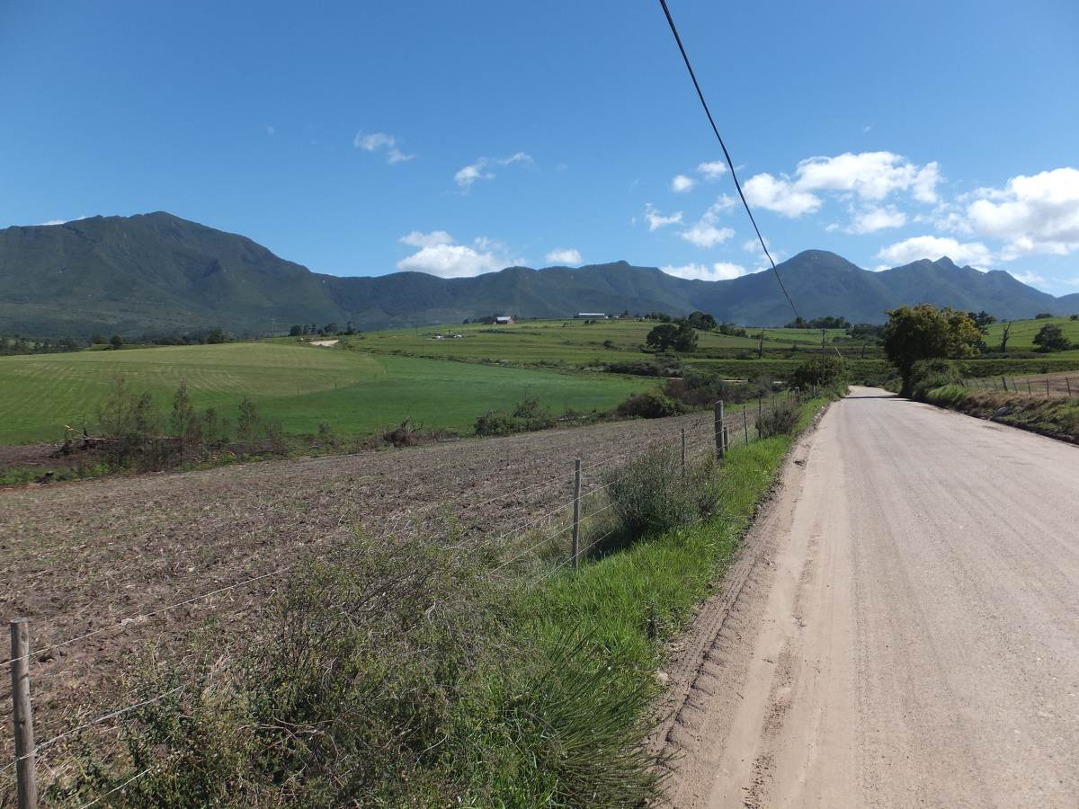

Photograph 1.5: View looking north over area that will be affected by power lines associated with Alternative 1

Alternative Substation Site 2
Alternative 2 is located on agricultural land ~ 300 m west of the existing 132 kV Blanco substation (Photograph 1.6). The substation will be clearly visible from the Geelhoutboom Road. The land is owned by the van Greunen Boerdery CC. A residential dwelling and will be affected by the proposed site. The substation is also located within 300 m of the home and office of Nelius van Greunen. The power line route is ~ 2.9km in length and runs in north-westerly direction for approximately 1.2 km before swinging north and linking up with the Droerivier Proteus 400kV line. Along the first 1.2 km section the proposed route traverses agricultural land and runs within 200 m of the van Greunen farmstead. At the point where the line swings north it is located within 100 m of the homestead of Mr Christo Joubert. The northern section also passess directly over three labourer’s cottages located immediately to the north of the Geelhoutboom Road. After crossing the Geelhoutboom Road the route runs parallel to the access road to the dairy on the farm owned by the van Rensburgs (Portion 61 of Farm Geelhoutboom 217). This road runs along a ridge line that forms the western boundary of the small valley affected by the power line routes associated with Alternative 1, 2 and 4. The power line will therefore be highly visible. The road also provides access to Morningside Farm and Arendsrus Guest House (Photograph 1.7 and 1.8). The area traversed by the power line is irrigated pasture land owned by the van Rensburg’s that is used for dairy farming.

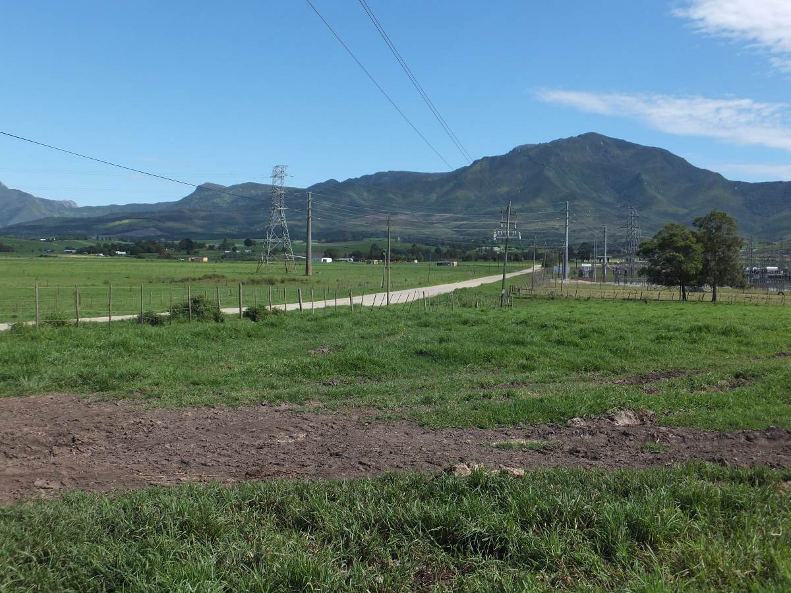

Photograph 1.6: View looking north over location of substation Alternative 2 site with Blanco substation on right

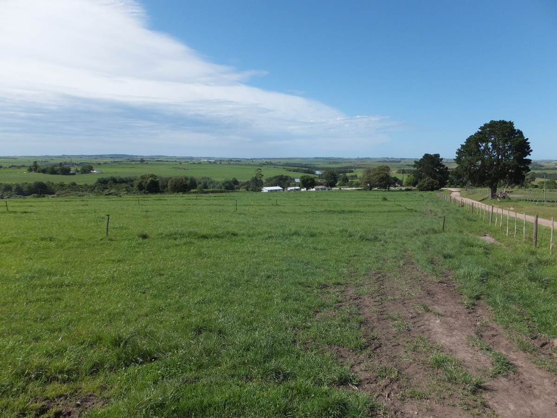

Photograph 1.7: View looking south along power line route associated with Alternative 2 and 4

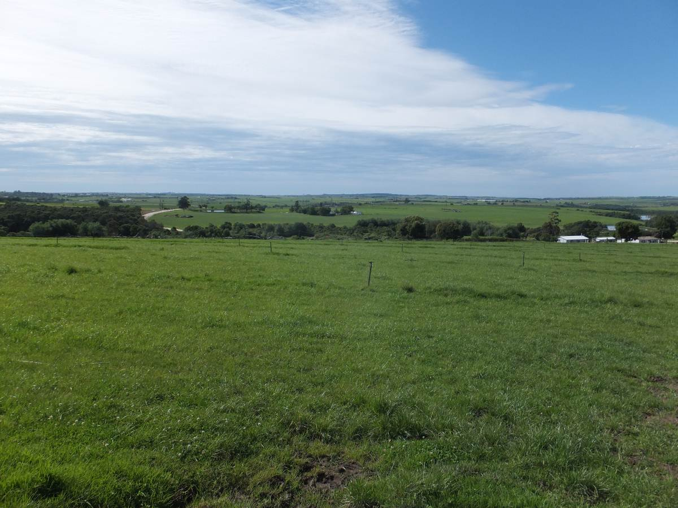

Photograph 1.8: View looking south over valley that will affected by power lines associated with Alternative 2 and 4

Alternative Substation Site 3
Alternative 3 is located ~ 1.8 km to the north-east of the existing substation and is located on the south eastern slope of low hill. The area was previously plantation area and has been recently cleared of alien tree species. The power line route is ~ 1.7km in length and runs in north-westerly direction from Alternative 3 to the Droerivier Proteus 400kV line. The proposed route runs cuts across the entrance to Farm Uitsig, which is an established wedding venue (Photograph 1.9). The route also traverses agricultural land to the south of Uitsig Farm and access road to Groeneweide Farm, which has an up-market guest house on the property (Photograph 1.10). The power lines will also be clearly visible from the labourers cottages located on Groeneweide. The southern and eastern boundary of the Groeneweide property is also traversed by the Droerivier Proteus 400kV line (Photograph 1.11).

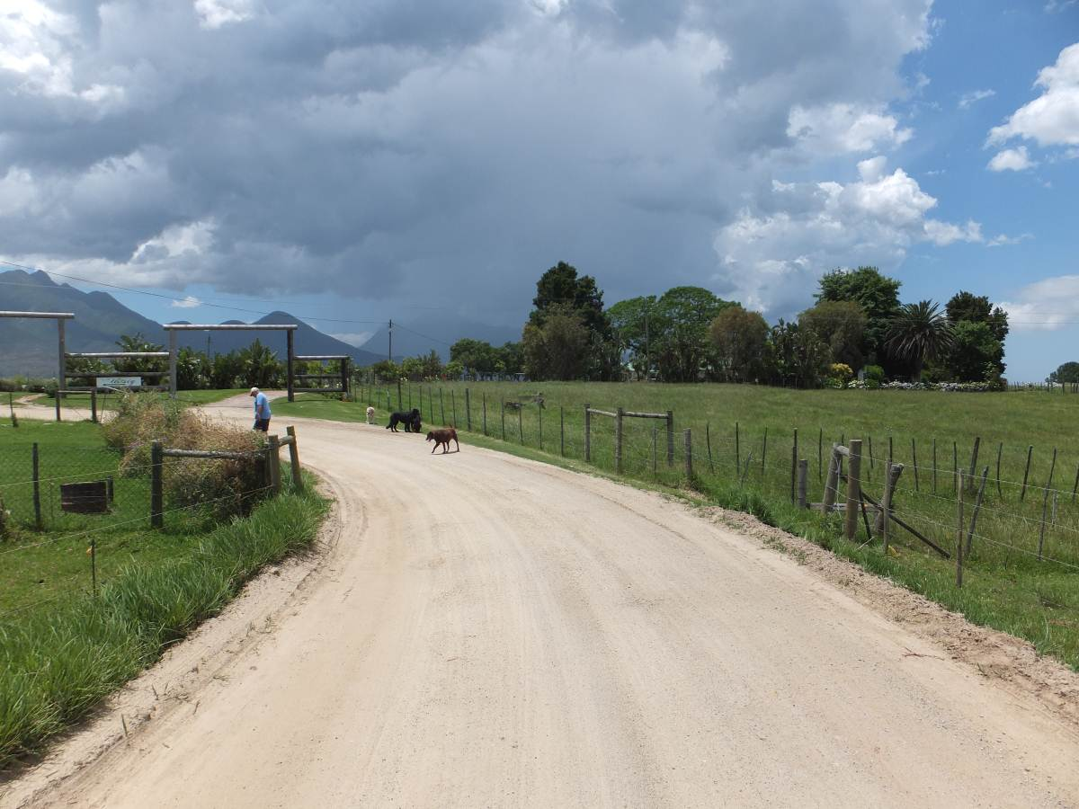

Photograph 1.9: View of entrance to Uitsig wedding and event venue that would be impacted by power lines associated with Alternative 3 and 6

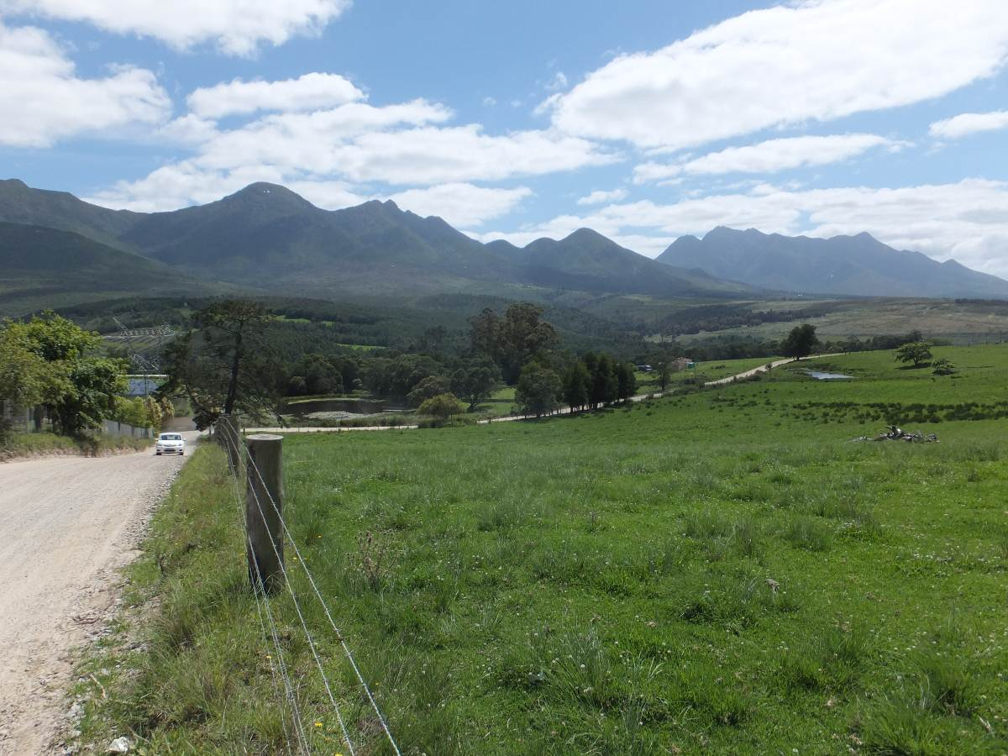

Photograph 1.10: View looking east over area that would be affected by power lines associated with Alternative 3 and 6

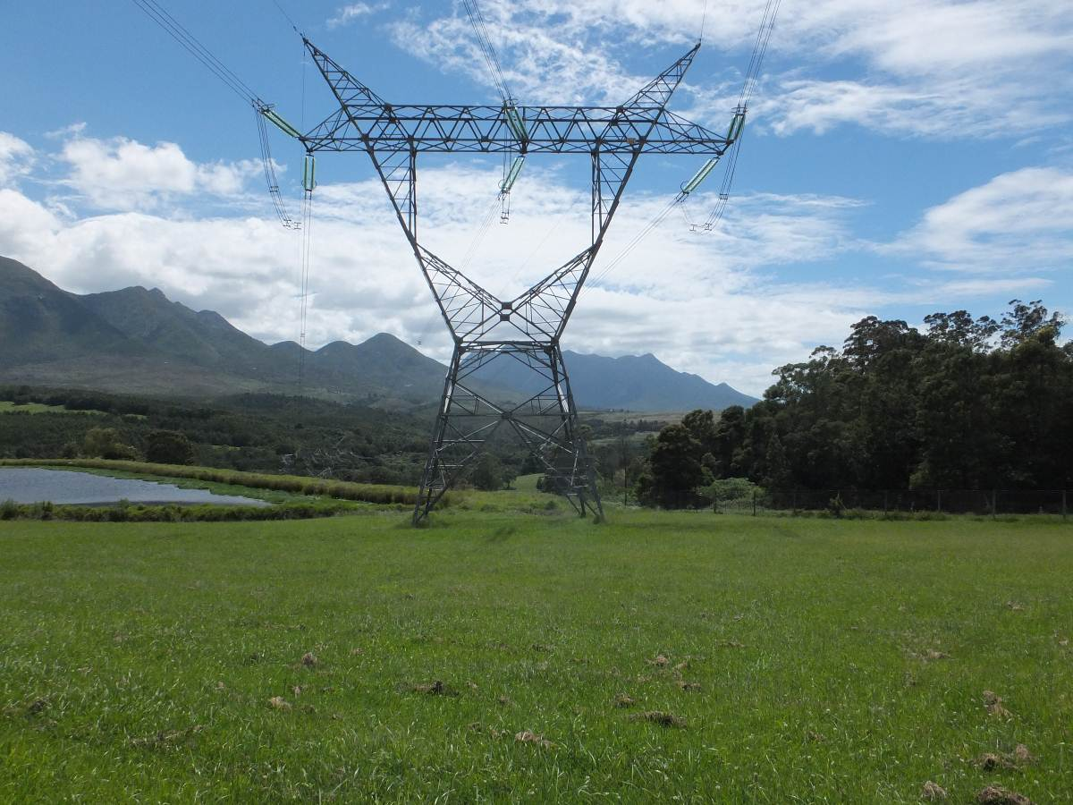

Photograph 1.11: Droerivier Proteus 400kV line on Groeneweide Farm

Alternative Substation Site 4
Alternative 4 is located ~ 1.2 km to the south west side of the existing 132 kV Blanco substation on property owned by Plattner Estates (Pty) Ltd (Portion 28 and 43 of Farm Klynefontein). The property has been developed as a horse stud farm (Photograph 1.12). Based on the information provided by the owners ~ R 30 million has been invested in the property (excluding purchase price). The formal component of the stud farm, including the stables and paddocks are located to the west of the substation site. The area affected by the substation site is located in an area that appears to be used for grazing (Photograph 1.13). Representatives from Plattner Estates indicated that the affected area formed an integral component of the stud farm.

The power line route is ~ 3.7km in length and runs in northerly direction for ~ 1 km before swinging north east for ~ 1 km from where it swings north and follows the same alignment of Alternative 2. The substation site and the first two 1 km sections of the power line are located on the grazing area. The final section of the alignment is shared with the alignment for Alternative 2. This section is described above.

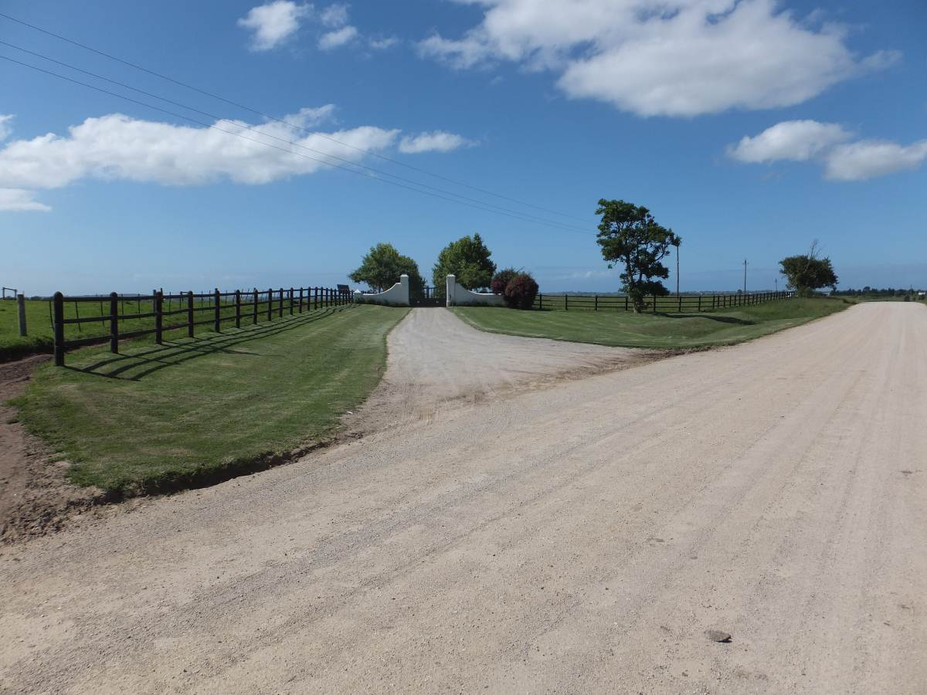

Photograph 1.12: Entrance to stud farm

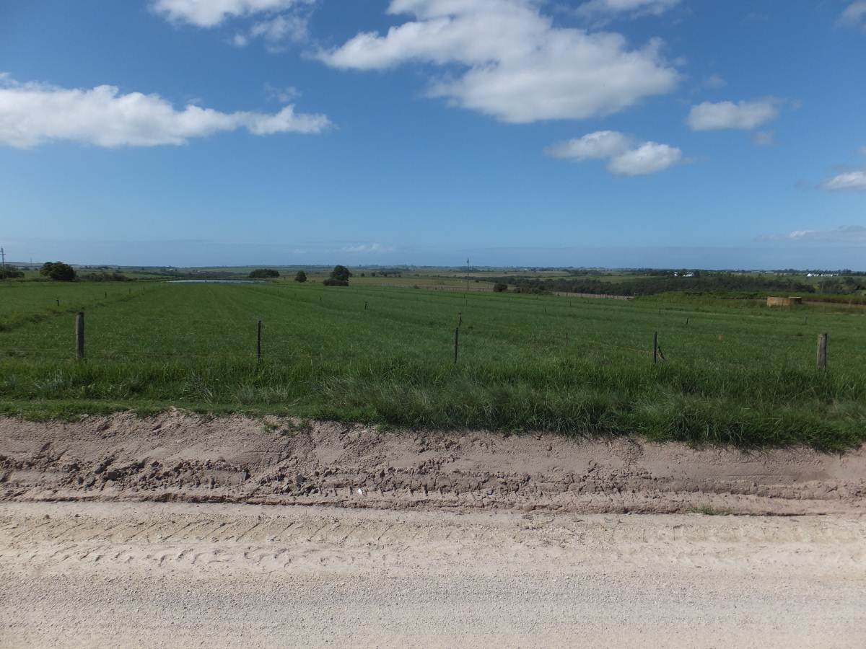

Photograph 1.13: View looking south over area that would be affected by power lines associated with Alternative 4

Substation Site 5
Alternative 5 is located in foothills of the Outeniqua Mountains, ~ 4.5 km north east of the existing 132 kV Blanco substation (Photograph 1.15 and 1.16)). A small forestry station is located immediately to the north of the proposed site (Photograph 1.17). Access to the site is via a gravel road that joins up with the R404 to the south. The power line route is ~ 4.1km in length and runs in easterly direction from Alternative 5 to the Droerivier Proteus 400kV. The proposed route follows the alignment of an existing power line that runs along the foothills of the Outentiqua Mountains. The land is owned by the Department of Forestry and consists of alien forestry plantations.

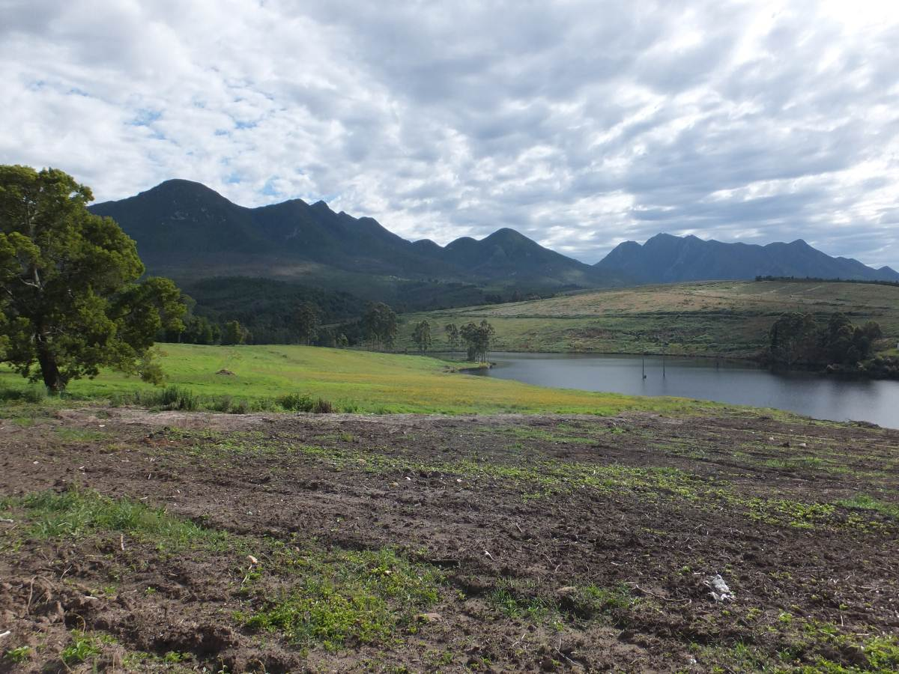

Photograph 1.15: View from access road to Farm Uitsig looking north east towards site for substation associated with Alternative 5

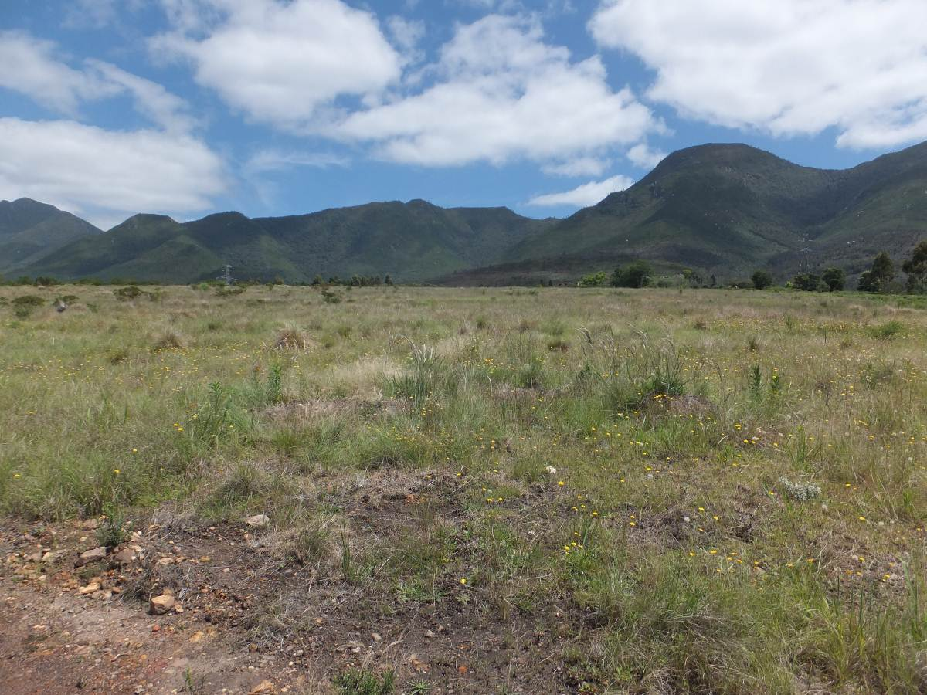

Photograph 1.16: View of Alternative 5 site

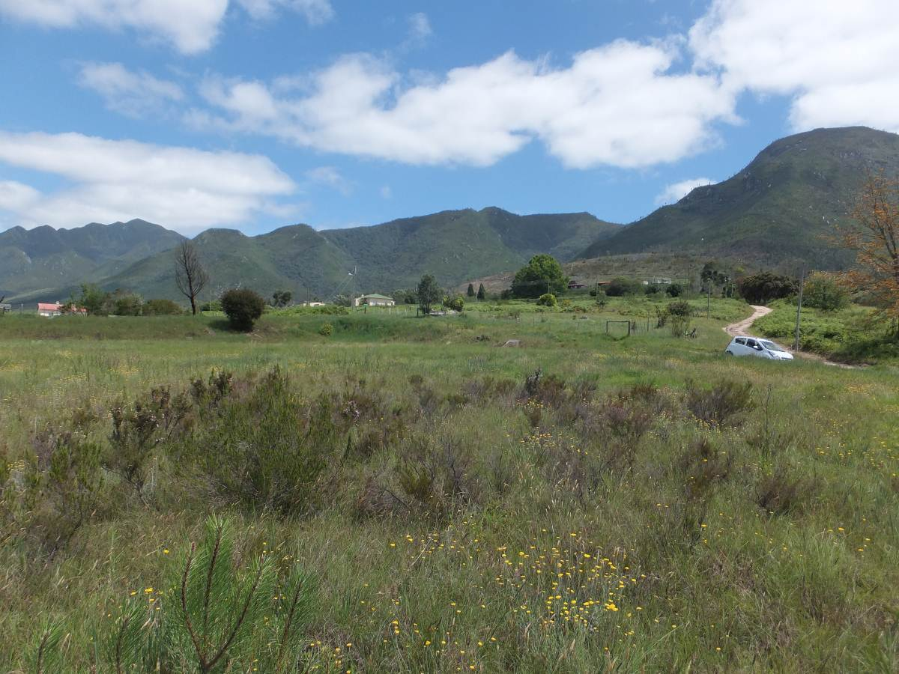

Photograph 1.17: Forestry station houses to the north of Alternative 5 site

Alternative Substation site 6
Alternative 6 is located between Alternative 1 and 3, ~ 500 m north-east of the Geelhoutboom Road. The substation will be clearly visible from the Geelhoutboom Road. The area was previously plantation area and has been recently cleared of alien tree species. The power line route is ~ 2 km in length and runs in north-westerly direction from Alternative 6 to the Droerivier Proteus 400kV line. The alignment is essentially the same as the alignment for Alternative 3. The proposed route runs cuts across the entrance to Farm Uitsig, which is an established wedding venue (Photograph 1.18). The route also traverses agricultural land to the south of Uitsig Farm and access road to Groeneweide Farm, which has an up-market guest house on the property. The power lines will also be clearly visible from the farm house to the east of the venue, which are located ~ 50 m to the east of the proposed alignment.

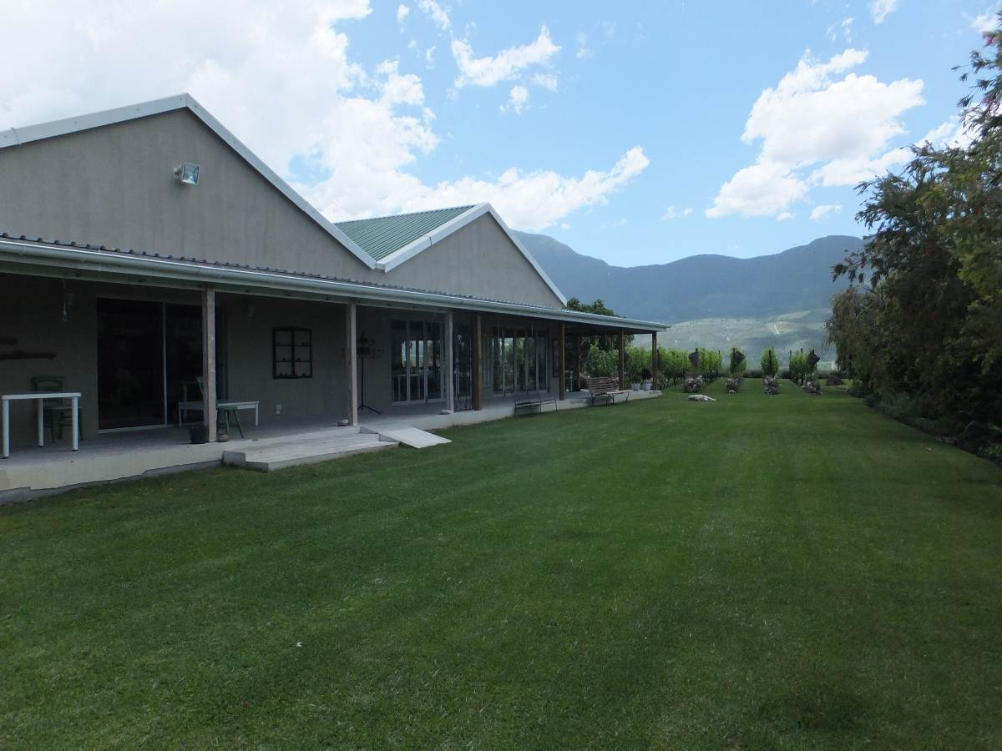

Photograph 1.18: Wedding and events venue on Farm Uitsig

PPROACH TO STUDY

The approach to the SIA study is based on the Western Cape Department of Environmental Affairs and Development Planning Guidelines for Social Impact Assessment (February 2007). These guidelines are based on international best practice. The key activities in the SIA process embodied in the guidelines include:

- Describing and obtaining an understanding of the proposed intervention (type, scale, and location), the settlements, and communities likely to be affected by the proposed project.
- Collecting baseline data on the current social and economic environment.
- Identifying the key potential social issues associated with the proposed project. This requires a site visit to the area and consultation with affected individuals and communities. As part of the process a basic information document was prepared and made available to key interested and affected parties. The aim of the document was to inform the affected parties of the nature and activities associated with the construction and operation of the proposed development to enable them to better understand and comment on the potential social issues and impacts.
- Assessing and documenting the significance of social impacts associated with the proposed intervention.
- Identifying alternatives and mitigation measures.

In this regard the study involved:

- Review of baseline socio-economic data;
- Review of relevant planning and policy frameworks for the area;
- Site specific information collected during the site visit to the area and interviews with interested and affected parties;
- Review of information from similar studies, including the EIAs undertaken for power lines;
- Identification and assessment of the social issues associated with the proposed project.

The identification of potential social issues associated with proposed facility is based on observations during the project site visit, review of relevant documentation, experience with similar projects and the general area. Annexure A contains a list of the secondary information reviewed and interviews conducted. Annexure B summarises the assessment methodology used to assign significance ratings to the assessment process.

Definition of social impacts
Social impacts can be defined as “The consequences to human populations of any public or private actions (these include policies, programmes, plans and/or projects) that alter the ways in which people live, work, play, relate to one another, organise to meet their needs and generally live and cope as members of society. These impacts are felt at various levels, including individual level, family or household level, community, organisation or society level. Some social impacts are felt by the body as a physical reality, while other social impacts are perceptual or emotional” (Vanclay, 2002).

When considering social impacts it is important to recognise that social change is a natural and on-going process (Burdge, 1995). However, it is also important to recognise and understand that policies, plans, programmes, and/or projects implemented by government departments and/or private institutions have the potential to influence and alter both the rate and direction of social change. Many social impacts are not in themselves “impacts” but change process that may lead to social impacts (Vanclay, 2002). For example the influx of temporary construction workers is in itself not a social impact. However, their presence can result in range of social impacts, such as increase in antisocial behaviour. The approach adopted by Vanclay stresses the importance of understanding the processes that can result in social impacts. It is therefore critical for social assessment specialists to think through the complex causal mechanisms that produce social impacts. By following impact pathways, or causal chains, and specifically, by thinking about interactions that are likely to be caused, the full range of impacts can be identified (Vanclay, 2002).
An SIA should therefore enable the authorities, project proponents, individuals, communities, and organisations to understand and be in a position to identify and anticipate the potential social consequences of the implementation of a proposed policy, programme, plan, or project. The SIA process should alert communities and individuals to the proposed project and possible social impacts, while at the same time allowing them to assess the implications and identify potential alternatives. The assessment process should also alert proponents and planners to the likelihood and nature of social impacts and enable them to anticipate and predict these impacts in advance so that the findings and recommendations of the assessment are incorporated into and inform the planning and decision-making process.
However, the issue of social impacts is complicated by the way in which different people from different cultural, ethic, religious, gender, and educational backgrounds etc. view the world. This is referred to as the “social construct of reality.” The social construct of reality informs people’s worldview and the way in which they react to changes.

Timing of social impacts
Social impacts vary in both time and space. In terms of timing, all projects and policies go through a series of phases, usually starting with initial planning, followed by implementation (construction), operation, and finally closure (decommissioning). The activities, and hence the type and duration of the social impacts associated with each of these phases are likely to differ.

ASSUMPTIONS AND LIMITATIONS

Assumptions

Technical suitability
It is assumed that all of the alternatives are technically feasible.

Strategic importance of energy supply
The strategic importance of providing ensuring reliable energy supply, which includes the provision of the required distribution infrastructure, is recognised.

Fit with planning and policy requirements
Legislation and policies reflect societal norms and values. The legislative and policy context therefore plays an important role in identifying and assessing the potential social impacts associated with a proposed development. In this regard a key component of the SIA process is to assess the proposed development in terms of its fit with key planning and policy documents. As such, if the findings of the study indicate that the proposed development in its current format does not conform to the spatial principles and guidelines contained in the relevant legislation and planning documents, and there are no significant or unique opportunities created by the development, the development cannot be supported.

However, the study recognises the technical, spatial and land use constraints associated with the provision of distribution networks for electricity.

Limitations
Demographic data
The information contained in some of the key policy and land use planning documents, such as Integrated Development Plans etc., may, in certain instances, not contain the latest data from the 2011 Census. Where possible the information has been up-dated with 2011 Census data.

SPECIALIST DETAILS

Tony Barbour, the lead author of this report is an independent specialist with 24 years’ experience in the field of environmental management. In terms of SIA experience Tony Barbour has undertaken in the region of 120 SIA’s and is the author of the Guidelines for Social Impact Assessments for EIA’s adopted by the Department of Environmental Affairs and Development Planning (DEA&DP) in the Western Cape in 2007.

Schalk van der Merwe, the co-author of this report, has an MPhil in Environmental Management from the University of Cape Town and has worked closely with Tony Barbour on a number of SIAs over the last ten years.

DECLARATION OF INDEPENDENCE

This confirms that Tony Barbour and Schalk van der Merwe, the specialist consultants responsible for undertaking the study and preparing the report, are independent and do not have vested or financial interests in proposed project being either approved or rejected.

REPORT STUCTURE

The report is divided into five sections, namely:

- Section 1: Introduction
- Section 2: Summary of key policy and planning documents relating to the project and the study area in question
- Section 3: Overview of the study area
- Section 4: Identification and assessment of key social issues
- Section 5: Summary of key findings and recommendations.

SECTION 2: POLICY AND PLANNING ENVIRONMENT

INTRODUCTION

Section 2 provides an overview of the most significant policy documents of relevance to the proposed development, namely:

- Western Cape Spatial Development Framework (PSDF) (2009);
- George Municipality Draft 2012-2017 Integrated Development Plan (2012);
- George Municipality Spatial Development Framework (2013);
- Draft Blanco Structure Plan (2009).

Western Cape Spatial Development Framework (2009)

The Western Cape Provincial Spatial Development Framework (PSDF) (2009) gives provincial-level expression to, and is explicitly aligned with, the National Spatial Development Perspective (NSDP) (2006). The PSDF was endorsed by Cabinet (PGWC) in June 2009, and is approved as a Structure Plan in terms of LUPO. It constitutes the fundamental policy instrument with regard to the spatial dimension of all development planning in the Western Cape. The PSDF is due for revision this year (2014).

With regard to the EDM, the PSDF identifies the following key spatial issues:

- High levels of in-migration;
- Shallow economic base, mainly tourism and construction;
- Water shortages; and,
- The future of the "Garden" aspect of the Garden Route.

The PSDF are stresses the importance of promote urban compaction and densification in George and Mossel Bay in particular;

With reference to the proposed project the siting of power lines is addressed under Objective 5.

Objective 5: Conserve the sense of place of important landscapes
The PSDF notes the vital importance of tourism to the Provincial economy. It further notes that scenic routes (such as the N2) and the adjacent countryside are memorable gateways to the Garden Route; that urban development has already substantially detracted from its visual quality, and that no further deterioration should therefore be permitted.

The PSDF therefore stipulates that, with regard to the siting and design of future power lines and other visibly substantial infrastructural development, the relevant provincial guidelines should be followed, and proposals should include provision for environmental, visual and heritage impact assessments.

The following policy directive is applicable:

HR26 (…) transmission lines (…) should be aligned along existing and proposed transport corridors rather than along point to point cross-country routes. (Mandatory directive)

The PSDF notes that the shortest-distance approach to the alignment of transmission lines raises issues of visual blight, unviable shaped land parcels, need for access roads and destruction of cultural landscapes. Where possible, future power lines should be aligned within existing and proposed combined road and/or rail linkage corridors that impact on the remainder of the landscape, especially if such alignment will not impact on cultural and scenic landscapes. Care should also be taken to avoid bird migration routes.

The PSDF notes that coordination will be required with electricity supply and distribution and telecommunication service providers' EIA processes to ensure that this policy is implemented (PSDF; 48).

George Municipality Draft 2012-2017 IDP

An Integrated Development Plan (IDP) is required in terms of the Municipal Systems Act (2000) of all South African municipalities. The George Draft 2012-2017 IDP represents the third generation IDP cycle. The Final document serves as the basic developmental framework and the basis for annual reviews of municipal performance for the period up to 2017.

The Municipal Vision is “George strives to be the best-medium sized city in the Country using all available resources sustainably to the benefit of the community in a growing and a thriving city”.

The Municipal Vision is “to provide affordable high quality services through effective governance, administration and fiscal discipline facilitating an environment that is conducive to economic growth and opportunities for all residents whilst ensuring the protection of our natural resources in a sustainable manner to provide a quality living environment for all”.

The George Municipal Council’s strategic agenda is based on the following five strategic goals:

- Deliver quality services in George;
- Grow George – The aim is to ensure an annual growth rate of 8%. Therefore infrastructure investment has to be a primary focus for the next 10 to 15 years.
- Keep George Safe & Green;
- Provide Good Governance;
- Ensure participation in George.

The Draft IDP also includes a situation analysis of the 25 Wards. Of relevance to this study, key identified challenges for Ward 22 include:

- lack of economic growth;
- lack of sufficient infrastructure discourages/ prevents growth of agri-tourism;
- Alcohol and drug abuse is a key issue;
- Clinic, refuse removal (big problem), access to other services seen as needs;
- Providing Farm worker housing.

Those for Ward 1 (Blanco) included high unemployment, especially under the youth, and substances abuse, linked to a lack of recreational facilities (George, 2012).

George Municipality Spatial Development Framework (2013)

After an SDF process stretching back to 2003, the Final George SDF was adopted in 2013. The SDF gives spatial expression to George LM’s IDP strategy and objectives until 2017. The SDF has been submitted to DEA&DP for approval as Structure Plan.

The SDF settlement strategy is based on the principles of a hierarchy of interdependent places, focusing productive investment in the regional centre of George, in support of its emergence as a fully-fledged garden city that is socially integrated and has a diversified economic base.

The place-role of Greater George (i.e. George Central, George SE, Blanco, Pacaltsdorp, Thembalethu) is defined as Regional commerce & service centre; administrative centre; industrial node; transport and logistics hub; emerging city in the SDF. The Geelhoutboom area, which is where the study are is located, is defined as significant agricultural area (Figure 2.1).

Figure 2.1: SDF Environmental and Rural Spatial Concept and Rural Hierarchy (Source: SDF, Figure 8).

A review of the relevant SDF maps indicates:

- The study area falls within an intensive agriculture area, as indicated in Figure 2.1. The area to the north of the site is defined as a natural area and is made up of the Ounteniqua Mountains (SDF; Map 10).
- The study area and the proposed sub-station sites and associated power lines are located ~ 6 km west of the 2023 George Urban Edge, which is associated with Blanco. The nearest proposed project substation (Alternative 6) is located ~5.3 km west of the Urban Edge (Blanco) (SDF; Map 5);
- The study area is not located in an area that has been identified as the future growth direction of George. The future area identified for growth is located to south of the N2, in an area that is located to the south and west of Pacaltsdorp (Map 6);
- The study area is not located within closed proximity to any future residential areas. The nearest residential area is Blanco, which is located ~ 6-8 km from the study area (SDF; Map 8);

SDF Provisions with regard to the rural area
With regard to the management of rural areas the SDF details a development strategy for the Municipality’s rural areas that focuses on maintaining ecologically functional and economically productive rural landscapes within which, amongst others:

- The entire rural area is managed to sustain ecosystem services (e.g. supply of clean water);
- Productive agricultural and forestry areas are protected; and
- Scenic landscapes and features are safeguarded.

The SDF specifies climate change mitigation measures, delineates the rural area into Spatial Planning Categories (SPCs), and provides guidelines on what land uses are suitable in the different SPCs.

Provisions with regard to the Blanco area
With regard to the nearby Blanco area (and its agricultural hinterland) the SDF provides the following:

- The Municipality will maintain the present environmental, rural and settlement character of Blanco;
- It will maintain ‘tight’ urban edges to protect the rural character of the area;
- It will apply land use management guidelines to protect the human scale and pastoral character of the village (including the placement of buildings close to street boundaries) (Objective 1, Strategy c.ii).
- Blanco CBD/ Blanco town centre is suitable for development as second order business node containing a mix of residential, commercial and public facilities (SDF Table 3);
- Sensitive mixed use development and densification along major routes (George Street and Montagu Street) should be supported;
- Infill residential development to densities of 20-30 units/ ha on identified vacant land parcels is suitable for the Blanco urban area (SDF Table 5).

Environmental Integrity and Assets
Safeguarding the George LM’s Environment is and natural assets are identified as a major policy objective. The General Policy Guidelines that are relevant to the proposed project include:

- Protect natural and productive resources;
- Protect the Garden Route identity;

Relevant key strategies include:

- Safeguard scenic landscapes and features;
- Safeguard the municipality’s farming and forestry areas as productive landscapes, equal in value to urban land (SDF 4.5.3).

Draft Blanco Structure Plan (2009)

The Draft Blanco Structure Plan (or Spatial Development Plan – SDP) is one of 11 SDPs which supplement the George LM SDF. These SDPs provide more area-specific guidance. The Draft Blanco SDP essentially covers the Blanco/ Fancourt area and rural area immediately to west, approximately 4-5 km east of substation sites. The study area is therefore not covered in the SDP.

Information on general context, sense of place, etc. has been incorporated into the Baseline description in Section 3.

SECTION 3: OVERVIEW OF STUDY AREA

INTRODUCTION

Section 3 provides an overview of the study area with regard to:

- The general location and administrative context;
- Study area communities;
- The demographic context; and,
- The economic context.

ADMINSTRATIVE CONTEXT

The study area is located in the George Local Municipality (GLM) in the south-eastern portion of the Eden District Municipality (EDM)(Figure 3.1). The GLM (WC044) is a category B-Municipality and is one of seven local municipalities that make up the EDM (DC4). The George LM borders onto the Mossel Bay LM to the west, the Oudshoorn LM to the northwest, the Bitou and Knysna LMs to the southeast (all of which form part of the EDM), and, the Baviaans LM to the northeast and Kou-Kamma LM to the east, both of which are located in the Eastern Cape Province.

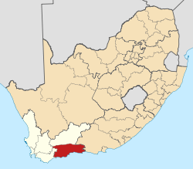 | 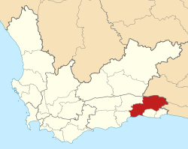

Figure 3.1: Location of Eden DM (left) and George LM within the Western Cape Province (source: Wikipedia)

In terms of geographic size and gross domestic product (GDP), the EDM the third largest district economy in the Western Cape, after the City of Cape Town and the Cape Winelands District. The EDM made up ~10% of the WCP’s population in 2011.

The city of George is the administrative seat of both the GLM and the EDM. As regional service centre the Greater George urban area is the economic hub of the municipal economy, with substantial service, commercial and light industrial sectors. George (town) is situated along the N2 (“Garden route”) between Cape Town (~420 km to the west) and Port Elizabeth (~330 to the east). This location has been considered as advantageous for investment particularly with regard to manufacturing, logistics and warehousing (George LM, 2012).

Other settlements in the GLM include the villages of Wilderness and Herold’s Bay, various coastal resorts such as Kleinkrantz and Victoria Bay, rural areas such as Geelhoutboom, Herold, Hansmoeskraal and Waboomskraal, as well as Uniondale and Haarlem (George LM, 2012).

The GLM consists of 25 wards after the 2011 demarcation. The study area is located in Ward 22, “George Rural areas, Diepkloof, Sinksabrug, Waboomskraal, Harlod, Geelhoutboom, Bo-Dorp, Camphersdrif”, and essentially consists of the rural area located to the west of urban George (town) and Blanco. The Geelhoutboom area essentially corresponds to the immediate study area. The area is located ~5 km to the west of the George (Blanco) urban edge, south of the Outeniqua Mountains and is characterized by intensive agriculture and forestry (George LM, 2013). The settlement of Blanco, located approximately 5 km to the east of the proposed study area, constitutes Ward 1 (Eden DM municipal demarcation map series, 2011).

LOCAL COMMUNITIES

George
George is the sixth oldest town in South Africa, and, after the City of Cape Town, is ranked as the town with the greatest development potential in the Western Cape Province (WCP) (George LM, 2013). As indicated above, the town is the regional hub for the Southern Cape region. The town of George, as distinct from Blanco, is located to the north of the N2 ~8.5 km east of the study area. The large predominantly Coloured and Black townships of Pacaltsdorp and Thembalethu are located to the south of the N2l.

Although urban George accommodates 85% of the municipality’s population, it does not function as an integrated town but as an agglomeration of fragmented urban areas that reflect the legacy of apartheid spatial planning. Within the Greater George urban area there are significant disparities in living conditions, with a too high percentage of the population inadequately housed (many of the informal areas do not have access to basic services) (George LM, 2013).

George evolved from a DEIC timber post established in 1776 to exploit the timber resources of what was then known as “Outeniqualand” in reference to the pastoralist Outeniqua Khoi-Khoi whose ancestral land it comprised. Increasing accessibility attracted woodcutters to settle in the area, and by 1811 George was proclaimed as a town (named after George III). The town gained municipal status in 1837 (Wikipedia). The utilization of the forest trees led to such industries as furniture and wagon making. By 1910 several large sawmills had been established in the district. Timber for export was transported to coastal ports by ox wagon. The opening of the Montagu pass (1849), a railway line (1913) and the N12 (Outeniqua pass) in 1951 have progressively provided direct abscess to the interior beyond the coastal range (i.e. Outeniqua mountains).

Today George is modern city with sophisticated infrastructure, which includes banks, conference facilities, businesses and shopping centers. However, the town still retains its small town atmosphere. The town and surrounding area is also well-known for its world-class golf courses, including Fancourt, George Golf Course and Oubaai. The town does not have direct access to the beach, but nearby beaches include Victoria Bay (9km east of central George), Herolds Bay (18km southwest of the George city centre), and Wilderness (south-east of George).

Blanco
The original farms in the Blanco were registered between 1816 and 1875, all subsequently extensively subdivided. The Blanco area was expropriated by Colonial Government during the 1820’s when George was expanding as a town. The land was originally used for Government grazing. From 1845 to 1849, “Blanco” housed the construction headquarters during the construction of the Montagu pass.

The opening of the pass in 1849 provided a direct link from Oudshoorn and the Klein Karoo to George. Blanco was situated along the road at the foot of the pass, and benefited substantially from passing trade, etc. In addition, Blanco got its present name, when Colonial Secretary John Montague (after whom the pass was named), named it “Whitesville”, in recognition of the services of the construction supervisor, Henry Fancourt White. A Latinized version (of “white”) was locally preferred, and “Blanco” stuck.

By the early 1920’s a full-fledged village had emerged, housing mainly members of various Churches on Government land grants. Small artisanal leather (tannery, shoes) industries flourished. During the 1910’s artisanal leatherworkers were actively recruited overseas. The rail link from George to Oudshoorn was completed in 1913.

Blanco’s fortunes suffered a severe blow when the Outeniqua Pass was opened in 1951, providing a more direct link between George and the Klein Karoo, and bypassing Blanco. In time local the craftsmanship-based and traditional small agricultural enterprises, as well as industrial and commercial enterprises, disappeared. From 1923 to 1973, the village was run by the Blanco Village Management Board. Blanco was incorporated into the George Municipality in 1973. In time, Blanco lost its vibrancy as economic entity, as the focus shifted to George itself. Most of Blanco’s residents currently work in George.

The conversion of White’s original mansion in Blanco in 1987 into the 115-room Fancourt Hotel, (recently renovated to “The Manor House at Fancourt”) and the subsequent development of three Gary Player golf courses course and the associated up-market residential estate, referred to as Fancourt, has benefitted Blanco and the town of George as a whole. However, the 2009 Draft Blanco SDP notes that Blanco has not fully tapped into the benefits associated with visitors to Fancourt. The potential has however been recognized. Currently a number of small arts and crafts businesses cater for the passing tourist trade. Tourism and accommodation-related enterprises are present, but there is room for further growth. The special charm and character of the original village – which sets it apart from other villages and George in the region - has been recognized by developers, and should be protected as an asset (George LM, 2009).

The rural landscape immediately around Blanco displays a fine-grained sub-division, creating a varied patchwork of mainly agriculturally-orientated land uses. Traditional landscape patterns such as windbreaks persist, imparting a sense of fields and pastures being “rooms” within the landscape (George LM, 2009).

Rural area west of George
The area to the west of George up to the Groot Brak River was traditionally regarded as the bread basket of Outeniqualand during the 18th and 19th centuries, serving mainly the local woodcutter community. Agriculture remains the key economic activity in the area. Activities include dairy, fresh produce and hops. Berry farming, a more recent diversification, also serves as a tourism drawing card. These activities are also major sources of local employment provision (George LM, 2009).

With regard to area sense of place, the Draft SDP notes that Blanco and its agricultural hinterland form part of a regional settlement pattern between the Outiniqua Mountains and the Indian Ocean. The unique sense of place is derived from the backdrop of the mountain and the relative proximity of the ocean, of being on a narrow, in places very fertile, coastal plain. River corridors and a productive agricultural environment are further key structuring elements. The Draft Blanco SDP notes that these elements (views and sense of landscape) also make the area attractive to tourists and developers (George LM, 2009).

The IDP also notes that the landscape in the George LM is greatly transformed, with only ~26.6% natural vegetation cover remaining (in contrast to 45.9% and 64.8% in the Knysna LM and Bietou LM respectively). Intensive agriculture, forestry and urbanization are key factors, with the former two greatly contributing to the sense of place and landscape character of the fertile coastal plain west of George (town) south of the mountain, i.e. the study area (George LM, 2012). These characteristics also apply to the study area.

DEMOGRAPHIC PROFILE

Census 2011 information presented below is at local municipal level, and therefore covers the entire George LM. Disaggregated data for the western George agricultural area of Ward 22 could not be sourced. The StatsSA Municipal Fact Sheet (StatsSA, 2013) was used as key reference. Analysis is supplemented with information contained in the Eden Regional Profile (Working paper) which was compiled by Provincial Treasury in 2012.

When considering the information it should be noted that DMA was only added tto the LM in 2011, as part of the Census demarcation. The 2001 data set therefore represents “George LM minus DMA”.

Demographic information
As indicated in Table 3.1 the George LM population has grown by 2.24% per year in the period between the 2011 and 2011 Census. However, part of this growth was as a result of the incorporation of the DMA into the LM. In relative terms, the LM is home to about 33.7% of the DM’s population and 3.4% of that of the WCP.

Census 2011 information further indicates that, with regard to racial groups, the Coloured group was by far the most predominant in the Eden DM (84.8%). This profile is somewhat different with regard to George, where the Coloured group accounted for 50.4% in 2011, followed by the Black (28.2%), and Whites (19.7%), in other words indicating a more balanced racial mix. With regard to age structure, the George population shows a slight shift over the decade period towards the older cohorts, with the portion of the population under 15 having decreased from 28.9% to 26.3%.

Significant changes over the period are especially noticeable with regard to employment, specifically decreases in overall unemployment (-7.1%) and youth unemployment (-6.9%) in the George LM. Both rates are also lower for the George LM (20.7%; 27.6%) than for the DM (22.5%; 33.9%). The Eden DM had a Gini coefficient of 0.56 in 2011 – the lowest of all the DMs in the province, and lower than that of the City of Cape Town (0.57). George also had a coefficient of 0.56, but trailed Hessequa (0.51), Mossel Bay (0.52) and Knysna (0.55) (Provincial Treasury, 2012).

Based on information provided by the Western Cape Department of Education in 2012, 33 594 learners on all levels were enrolled in the George LM, accounting for 34% of the DM’s total enrolment. The learner-teacher ratio was 32.1%, around mid-range for Eden municipalities. The George high school drop-out rate was 37.9% - not quite as high as Kannaland (47.2%), but significantly higher than Oudshoorn (26.6%). The 2011 George matric pass rate was the second highest in the DM (91.4%)(Provincial Treasury, 2012).

Table 3.1: Overview of key socio-economic indicators for the Eden and George Municipalities

ASPECT | Eden  2011 | George  2001 | George  2011 | George  CHANGE
Population | 574 265 | 149 436 | 193 672 | +2.24% p.a.
Households | 164 110 | 38 867 | 53 551 | 37.7%
Household size (average) | 3.3 | 3.7 | 3.4 | -0.3 persons
% Female headed households | 33.9 | 30.9 | 33.2 | 2.3%
Sex Ratio (males per 100 females) | 95.8 | 95.9 | 96.9 | +1%
Dependency ratio per 100 (15-64) | 50.7 | 51.8 | 48.6 | -3.2%
% Population <15 years | 25.9 | 28.9 | 26.3 | -2.6
% Population 15-64 | 66.3 | 65.8 | 67.3 | +1.5
% Population 65+ | 7.8 | 5.3 | 6.4 | +1.1
Unemployment rate (official)  - % of economically active population | 22.5 | 27.8 | 20.7 | -7.1
Youth unemployment rate (official)  - % of economically active population 15-34 | 33.9 | 34.5 | 27.6 | -6.9
Gini coefficient | 0.56 | 0.58 | 0.56 | -0.2
No schooling - % of population 20+ | 3.7 | 8.4 | 3.9 | +4.5
Higher Education - % of population 20+ | 10.9 | 9.7 | 11.6 | +1.9
Matric - % of population 20+ | 28 | 23.9 | 29.1 | +5.2

Source: Compiled from StatsSA Census 2011 Municipal Fact Sheet; Provincial Treasury, 2012.

Access to municipal services
As indicated in Table 3.2, with the exception of a small decrease in the % of properties wholly or partially owned by households (-1.9%), all other indicators for the George LM show significant improvement in terms of service levels and access to formalized housing over the last 10 year Census period. Specifically impressive is the increase (+11.8%) in the number of dwellings with access to piped water inside the dwelling. Census data further indicates that the number of households with access to electricity is currently at 91%, almost the same as for Eden, and somewhat lower than the provincial average of 93.4%, but well above the national average of 84.7%

According to the George Human Settlement Plan, the housing backlog was at 18 230 in 2011, and is estimated to be growing by 6% per year (George LM, 2012).

Table 3.2: Overview of access to basic services in the Eden and George Municipalities

 | Eden  2011 | George 2001 | George 2011 | Change  (%)
Formal dwellings % of total | 83.8 | 80.9 | 83.9 | +3%
% dwellings owned by occupant | 55 | 50.9 | 49 | -1.9%
% households with access to flush toilet | 78.3 | 75.9 | 82 | +6.1%
% households with weekly municipal refuse removal | 86.4 | 82.2 | 88.1 | -5.9%
% households with piped water inside dwelling | 71.8 | 58.5 | 70.3 | +11.8%
% households which uses electricity for lighting | 91.1 | 86.7 | 91 | +4.3%

Source: Compiled from StatsSA Census 2011 Municipal Fact Sheet

HIV and access to health care
Information provided by the provincial Department of Health in 2012 indicates that a total of 18 primary health care facilities were located in George, in addition to a district hospital as well as a regional hospital, the only one in the DM (Provincial Treasury, 2012).

Additional information indicates that the HIV/ AIDS patient caseload has increased year-on-year for both the Eden and George municipalities since 2010. George accounted for 35.9% (3 377) of Eden’s total caseload by 2012. At the same time the roll-out of ART sites in George LM has also increased, from 2 in 2010 to 9 in 2012 (Provincial Treasury, 2012).

ECONOMIC OVERVIEW

The overview below focuses on the George LM, and is based on information contained in the 2012-2017 Draft George IDP, the 2013 SDF, and the 2012 Provincial Treasury Eden regional profile.

The EDM economy is the second largest of the district economies in the Western Cape after the CCT (73% of the Western Cape’s GDPR) and accounts for 7.3 % of the Western Cape GDP-R and 27.5 % of the non-Metro GDP-R. The value of the GDP-R generated during calendar 2010 amounted to R25.5 billion. GLM accounted for close to a third of the DM’s GDP-R (Provincial Treasury, 2012).

George recorded a growth rate of 4.06% from 2000 – 2010, in line with the Provincial rate. Since 2007 the growth rate has slowed down significantly and for the period 2007 to 2010 only averaged 1.82%, in line with the global and national economic slowdown. Year-on-year increases have been recorded since 2009, and the recovery seems to be on-going, with increases in building plan submissions and approvals as indicator continuing to rise in 2011 (George LM, 2012).

When considering the growth in formal employment numbers the area shows the same trend of so called “jobless growth” as the remainder of South Africa. Average annual growth rates (DMA excluded) in formal employment was 0.82% for 1995 – 2000, and dropped to 0.24% for the period 2000 to 2009.

Employment generation in the area remains a challenge, as the real economy grew by 41% for the period 2001-2010, while formal employment grew by just over 17%, with a number of jobs also absorbed in the informal economy. This is indicative of economic growth taking place in sectors such as business and financial services which does not have high labour absorption rates.

Over the period 2000 to 2009 the total labour force in the George Municipal area grew at an average annual rate of 1.5%. Informal employment grew strongly over this period (8%) and served as a buffer to absorb those members of the labour force that could not be absorbed within the formal sector

Over the longer term the structure of the economy in George has shifted slightly away from primary and secondary sectors (mainly Agriculture, Forestry and Manufacturing) to a more service driven economy, specifically Finance, Insurance, Real Estate and Business Services. Construction while registering slower growth rates since 2008 did not decline in terms of real output (George LM, 2012).

When analyzing the contribution to employment per sector over time, Agriculture, Forestry and fishing registered a marked decline in employment numbers, from contributing around 13% to total employment in 1995 to only 4% in 2010. This can be attributed to automation in these industries, and therefore a drop in actual employment numbers and labour intensity. Manufacturing also recorded a decline in employment contribution, although not as steeply as in the primary sectors.

Construction showed strong employment growth between 2000 and 2010, but interestingly actual employment numbers in 2010 correlate to those in 1995, showing that over the longer term of 15 years, growth was minimal in this sector in terms of employment numbers. The Electricity, Gas and Water sector accounted for 0.3% of George LM employment opportunities in 2010.

Catering and accommodation services had the highest labour intensity, contributing 19 jobs per R1 Million GVA. Agriculture, Forestry and Fishing and Construction also contribute a higher percentage to employment numbers than in GVA, indicating a relatively higher labour intensity.

In terms of comparative ranking Agriculture, Forestry and Fishery shows location advantages, possibly due to the area’s unique contribution in terms of the forestry sector. There is relatively high location quotient based on employment attached to the secondary sectors, mainly as a result of the Construction sector, which contributes 10.8% to total employment and records very high location quotients based on both GVA and Employment.

According to the shift-share analysis only the quarrying, construction, communication and transport sectors grew in George not only due to national industry and general growth trends but also due to uniquely favorable local conditions. The area benefitted specifically from the “construction rush” during the middle 2000’s as it is a sought after holiday and second home destination.

The average consumption in George is calculated at 5 184 kWh, thus slightly higher than the national figure (4 532 kWh per capita). High income households have a significantly higher usage at about double this average.

Wages and remuneration per person employed in George is generally below the Western Cape and Cape Town figures. Overall remuneration is around 20% lower in George than in Cape Town. Remuneration in the Electricity sector is however almost 40% higher in George – this could point to a premium being paid for a scarce skill in the more rural area (63). The lower wages in the George area are generally offset by more affordable cost of living, when compared to Cape Town and other cities.

Agro-processing in George remains an attractive area for investment, with the need to ensure more value added locally in the processing of locally grown and produced agricultural products. A strong existing dairy cluster could be developed further against increased importance of the Southern Cape in South Africa’s dairy production.

Other indications are that George will continue to build on its existing position as regional hub for the Southern Cape – specifically in terms of retail and wholesale as well as financial and business services (George LM, 2012)

Tourism
The IDP notes that while Catering and Accommodation services contributed only 1.6% to total GVA in 2010, it contributed 4.4% in terms of employment. There are also linkages between this industry and other services relating to tourist activities (George LM, 2012).

Key George tourism assets are linked to the areas scenic natural and agricultural landscapes, its location along the Garden Route, Tsitsikamma National Park and coastal area. The Outeniqua Tourism Association (OTA) currently promotes a number of routes, among which the Outeniqua Country Hop Route. The Route currently stretches from Oudshoorn to Mossel Bay, via the George area, including the study area. The routes attractions are linked to its scenic setting at the foot of the Oteniqua Mountains and activities associated with the farms in the area. These include strawberry and herb farms, cheese and candle making, strawberry picking and horse riding (OTA website). The intention is to create a Route through the municipal region that is based on the successful Midlands Meander in the KZN Midlands (OTA website). Based on the information from the OTA website there are in the region of 12 tourist facilities/destinations associated with the Outeniqua Country Hop Route.

SECTION 4: ASSESSMENT OF KEY SOCIAL ISSUES

INTRODUCTION

Section 4 identifies the key social issues identified during the SIA study. The identification of social issues was based on:

- Review of project related information and baseline socio-economic data;
- Interviews with key interested and affected parties;
- Experience of the authors of the study area and the local conditions; and
- Experience with similar projects.

In identifying the key issues the following assumption is made:

- The alternative substation sites and associated power line routes are technically feasible.

IDENTIFICATION OF KEY SOCIAL ISSUES

The key social issues identified during the SIA can be divided into:

- The policy and planning related issues
- Local, site-specific issues

The local site-specific issues can in turn be divided into construction and operational related issues. These issues are discussed and assessed below.

POLICY AND PLANNING ISSUES

As indicated in Section 1.5, legislative and policy context plays an important role in identifying and assessing the potential social impacts associated with a proposed development. In this regard a key component of the SIA process is to assess the proposed development in terms of its fit with key planning and policy documents. However, the need to establish a new substation and associated power lines is noted. The aim of the review is therefore to identify the land use planning and policy documents that a bearing on the identification of a suitable site alternative.

The review of the relevant planning and policy documents was undertaken as a part of the SIA. The key documents reviewed included:

- Western Cape Spatial Development Framework (PSDF) (2009);
- George Municipality Draft 2012-2017 Integrated Development Plan (2012);
- George Municipality Spatial Development Framework (2013);
- Draft Blanco Structure Plan (2009).

Based on the review the following are relevant to the identification of a suitable site alternative.

With reference to the proposed project the siting of power lines is addressed under Objective 5.

Objective 5: Conserve the sense of place of important landscapes, of the Provincial spatial Development Framework, highlights the importance of tourism to the Provincial economy. The PSDF also stipulates that, with regard to the siting and design of future power lines and other visibly substantial infrastructural development, the relevant provincial guidelines should be followed, and proposals should include provision for environmental, visual and heritage impact assessments. The PSDF notes that the shortest-distance approach to the alignment of transmission lines raises issues of visual blight, unviable shaped land parcels, need for access roads and destruction of cultural landscapes.

The following policy directive is applicable:

HR26 (…) transmission lines (…) should be aligned along existing and proposed transport corridors rather than along point to point cross-country routes. (Mandatory directive)

The George SDF notes that productive agricultural areas should be protected and scenic landscapes and features safeguarded.

Based on the findings of the review Alternative 5 is the most compatible option in terms of the meeting the land use planning and policy documents that have a bearing on the identification of a suitable site alternative.

SOCIAL IMPACTS ASSOCIATED WITH THE CONSTRUCTION PHASE

Based the findings of the SIA the nature and significance of the construction related impacts associated with Alternative 1-4 and 6 will be similar. Only the affected landowners will differ. This is due to the location of the proposed substation sites and the affected land uses. Separate assessments have therefore not been undertaken for Alternative 1-4 and 6. The substation site associated with Alternative 5 is not located in an area that is being farmed. In addition the associated power lines do not cut across productive farm land. The significance of the construction related impacts will therefore differ. Alternative 5 has therefore been assessed separately.

The key social issues associated with the construction phase include:

Potential positive impacts
- Creation of employment opportunities

Potential negative impacts
- Impacts associated with the presence of construction workers on site
- Impact on farming operations;
- Impacts associated with movement of heavy vehicles during the construction phase.

Creation of employment opportunities
The construction related activities will create temporary employment opportunities which, in turn will create an opportunity for local George economy. The construction will be undertaken by contractors and the majority of the employment opportunities will be associated with the establishment of the substation component of the project.

The creation of employment opportunities will be the same for each of the six alternatives. The significance ratings therefore apply to each of the six alternatives.

Table 4.1: Impact assessment of employment and business creation opportunities during the construction phase (Alternative 1-6)

Nature: Creation of employment and business opportunities during the construction phase
 | Without Mitigation | With Enhancement
Extent | Local – Regional (3) | Local – Regional (4)
Duration | Short (2) | Short Term (2)
Magnitude | Low (4) | Low (4)
Probability | Highly probable (4) | Highly probable (4)
Significance | Medium (36) | Medium (40)
Status | Positive | Positive
Reversibility | N/A | N/A
Irreplaceable loss of resources? | N/A | N/A
Can impact be enhanced? | Yes
Enhancement : See below
Cumulative impacts: Opportunity to up-grade and improve skills levels in the area.
Residual impacts: Improved pool of skills and experience in the local area.

Assessment of No-Go option
The potential employment and economic benefits associated with the construction of the proposed project would be forgone.

Recommended enhancement measures
In order to enhance local employment and business opportunities associated with the construction phase the following measures should be implemented:

Employment
- Where reasonable and practical the contractors appointed by the proponent should appoint local contractors and implement a ‘locals first’ policy, especially for semi and low-skilled job categories. However, due to the low skills levels in the area, the majority of skilled posts are likely to be filled by people from outside the area.
- Where feasible, efforts should be made to employ local contactors that are compliant with Broad Based Black Economic Empowerment (BBBEE) criteria;
- Before the construction phase commences the proponent and its contractors should meet with representatives from the GLM to establish the existence of a skills database for the area. If such as database exists it should be made available to the contractors appointed for the construction phase.
- The local authorities, community representatives, and organisations on the interested and affected party database should be informed of the final decision regarding the project and the potential job opportunities for locals and the employment procedures that the proponent intends following for the construction phase.
- Where feasible, training and skills development programmes for locals should be initiated prior to the initiation of the construction phase.
- The recruitment selection process should seek to promote gender equality and the employment of women wherever possible.

Business
- The proponent should seek to develop a database of local companies, specifically BBBEE companies, which qualify as potential service providers (e.g. construction companies, catering companies, waste collection companies, security companies etc.) prior to the commencement of the tender process for construction contractors. These companies should be notified of the tender process and invited to bid for project-related work;
- The GLM, in conjunction with the local Chamber of Commerce and representatives from the local hospitality industry, should identify strategies aimed at maximising the potential benefits associated with the project.

Note that while preference to local employees and companies is recommended, it is recognised that a competitive tender process may not guarantee the employment of local labour for the construction phase.

Presence of construction workers in the area
The presence of construction workers poses a potential risk to family structures and social networks in the area, specifically local farm workers. This risk applies to each of the seven alternatives. While the presence of construction workers does not in itself constitute a social impact, the manner in which construction workers conduct themselves can affect the local community. In this regard the most significant negative impact is associated with the disruption of existing family structures and social networks. This risk is linked to the potential behaviour of male construction workers, including:

- An increase in alcohol and drug use;
- An increase in crime levels;
- An increase in teenage and unwanted pregnancies;
- An increase in prostitution; and
- An increase in sexually transmitted diseases (STDs).

Employing members from the local community to fill the semi and low-skilled job categories will reduce the risk posed by construction workers to local communities. These workers will be from the local community and form part of the local family and social network. In the case of the proposed development the majority of the construction workers are likely to be from local communities in the area. The potential risk posed by construction workers is therefore likely to be low. This applies to each of the alternatives.

While the potential threat posed by construction workers to the community as a whole is likely to be low with effective mitigation, the impact on individual members who are affected by the behavior of construction workers has the potential to be high, specifically if they are affected by STDs etc.

Table 4.2: Assessment of impact of construction workers on local communities (Option 2, 4 and 5)

Nature: Potential impacts on family structures and social networks associated with the presence of construction workers
 | Without Mitigation | With Mitigation
Extent | Local (2) | Local (1)
Duration | Medium Term for community as a whole (3)  Long term-permanent for individuals who may be affected by STD’s etc. (5) | Medium Term for community as a whole (3)  Long term-permanent for individuals who may be affected by STD’s etc. (5)
Magnitude | Low for the community as a whole (4)  High-Very High for specific individuals who may be affected by STD’s etc. (10) | Low for community as a whole  (4)  High-Very High for specific individuals who may be affected by STD’s etc. (10)
Probability | Probable (3) | Probable (3)
Significance | Low for the community as a whole (27)  Moderate-High for specific individuals who may be affected by STD’s etc. (57) | Low for the community as a whole (24)  Moderate-High for specific individuals who may be affected by STD’s etc. (51)
Status | Negative | Negative
Reversibility | No in case of HIV and AIDS | No in case of HIV and AIDS
Irreplaceable loss of resources? | Yes, if people contract HIV/AIDS. Human capital plays a critical role in communities that rely on farming for their livelihoods
Can impact be mitigated? | Yes, to some degree. However, the risk cannot be eliminated
Mitigation: See below
Cumulative impacts: Impacts on family and community relations that may, in some cases, persist for a long period. Also in cases where unplanned / unwanted pregnancies occur or members of the community are infected by an STD, specifically HIV and or AIDS, the impacts may be permanent and have long term to permanent cumulative impacts on the affected individuals and/or their families and the community.
Residual impacts: Community members affected by STDs etc. and associated impact on local community and burden services etc.

Assessment of No-Go option
The potential positive impacts on the local economy associated with construction phase would be foregone.

Recommended mitigation measures
The potential risks associated with construction workers can be mitigated. The aspects that should be covered include:

- Where possible, the proponent should make it a requirement for contractors to implement a ‘locals first’ policy for construction jobs, specifically semi and low-skilled job categories. This will reduce the potential impact that this category of worker could have on local family and social networks;
- The proponent should consider the establishment of a Monitoring Forum (MF) for the construction phase. The MF should be established before the construction phase commences and should include key stakeholders, including representatives from the local community, local councillors and the contractor. The role of the MF would be to monitor the construction phase and the implementation of the recommended mitigation measures. The MF should also be briefed on the potential risks to the local community associated with construction workers;
- The proponent and the contractors should, in consultation with representatives from the MF, develop a Code of Conduct for the construction phase. The code should identify what types of behaviour and activities by construction workers are not permitted. Construction workers that breach the code of good conduct should be dismissed. All dismissals must comply with the South African labour legislation;
- The proponent and the contractor should implement an HIV/AIDS awareness programme for all construction workers at the outset of the construction phase;
- The movement of construction workers on and off the site should be closely managed and monitored by the contractors. In this regard the contractors should be responsible for making the necessary arrangements for transporting workers to and from site on a daily basis;
- With the exception of security personnel, no construction workers should be permitted to stay overnight on the site.

Impacts associated with construction vehicles
Construction related activities, specifically the movement of vehicles, can create noise, dust and safety impacts. The Geelhoutboom Road is likely to provide the main access for Alternative 1-4 and 6. The access for Alternative 5 will be via the R 404. The Geelhoutboom Road is in the process of being surfaced which will significantly reduce the generation of dust. The movement of large, heavy loads during the construction phase also has the potential to create delays and safety impacts for other road users travelling along the Geelhoutboom Road. These impacts can however be mitigated by timing the trips to avoid times of the year when traffic volumes are likely to be higher, such as start and end of school holidays, long weekends and weekends in general. The proponent should also liaise with the local farmers in the area to ensure that measures are taken to avoid times of the year when the movement of heavy construction vehicles could impact on farming activities, such as during harvesting.

The impacts associated with construction vehicles will be similar for each of the six alternatives. The significance ratings therefore apply to each of the six alternatives.

Table 4.5: Assessment of the impacts associated with construction vehicles (Alternative 1-6)

Nature: Potential noise, dust and safety impacts associated with movement of construction related traffic to and from the site
 | Without Mitigation | With Mitigation
Extent | Local-Regional (2) | Local-Regional (1)
Duration | Medium Term (3) | Medium Term (3)
Magnitude | Low (4) | Low (4)
Probability | Probable (3) | Probable (3)
Significance | Low (27) | Low (24)
Status | Negative | Negative
Reversibility | Yes
Irreplaceable loss of resources? | No
Can impact be mitigated? | Yes
Mitigation: See below
Cumulative impacts: If damage to roads is not repaired then this will affect the farming activities in the area and result in higher maintenance costs for vehicles of local farmers and other road users. The costs will be borne by road users who were no responsible for the damage.
Residual impacts: Reduced quality of road surfaces and impact on road users

Assessment of No-Go option
Current status quo would be maintained and there would be no impact associated with construction vehicles

Recommended mitigation measures
The potential impacts associated with heavy vehicles and dust can be effectively mitigated. The aspects that should be covered include:

- Abnormal loads should be timed to avoid times of the year when traffic volumes are likely to be higher, such as start and end of school holidays, long weekends, harvesting time, and weekends in general etc.;
- The contractor must ensure that all damage caused to local farm roads by the construction related activities, including heavy vehicles, is repaired before the completion of the construction phase. The costs associated with the repair must be borne by the contractor;
- Dust suppression measures must be implemented for heavy vehicles such as wetting of gravel roads on a regular basis and ensuring that vehicles used to transport sand and building materials are fitted with tarpaulins or covers;
- All vehicles must be road-worthy and drivers must be qualified, made aware of the potential road safety issues, and need for strict speed limits.

SOCIAL IMPACTS ASSOCIATED WITH OPERATIONAL PHASE

Based on the findings of the SIA the impacts associated with Alternative 1-4 and 6 will be largely similar. As in the case of the construction phase, only the affected landowners will differ. This is due to the location of the proposed substation sites and the affected land uses. Separate assessments have therefore not been undertaken for Alternative 1-4 and 6. Where there are differences these are discussed in the text. The substation site associated with Alternative 5 is not located in an area that is being farmed. In addition the associated power lines do not cut across farm land. The significance of the operational phase impacts will therefore differ. Alternative 5 has therefore been assessed separately.

The key social issues affecting the operational phase include:

Potential positive impacts
- Provision of energy infrastructure

Potential negative impacts
- Impact on farming operations;
- Impact on tourism activities;
- Impact on sense of place and character of the area.

Provision of energy infrastructure
Eskom have indicated that there is a need to up-grade the existing power supply and distribution network in the area in order to meet the energy needs associated with future economic growth and development in the Southern Cape region. Each of the Alternatives (1-6) meets the technical requirements to accommodate the future energy need for the Southern Cape region. However, as indicated below, Alternative 5 is the preferred alternative.

Table 4.6: Assessment of energy infrastructure provision (Alternative 1-6)

Nature: Benefits associated with ensuring that the energy needs associated with future economic growth and development in the Southern Cape region are met
 | Without Mitigation | With Mitigation  (the mitigation implies the selection of the Alternative with the least impact)
Extent | Local and Regional (4)
Duration | Permanent (5)
Magnitude | High (8)
Probability | Definite (5)
Significance | High (75)
Status | Positive
Reversibility | Yes
Irreplaceable loss of resources? | No
Can impact be mitigated? | Yes
Enhancement: See below
Cumulative impacts: Positive impact on ability for the region of accommodate future economic growth due to inadequate energy supply and distribution network
Residual impacts: See cumulative impacts

Recommended mitigation measures
Alternative 6 should be developed and the preferred option.

Impact on farming operations
The establishment of the substations would result in a permanent loss of land. In the case of Alternative 1-4 and 6 the land affected is productive farm land. In terms of the power line routes, the power line routes for Alternative 1-4 and 6 all traverse productive farm lands. In some instances, such as Alternative 2 and 1, irrigated farm lands area affected. The landowners that stand to be most impacted are the ones on whose property the proposed substations are located. These are Nelius van Greunen (Alternative 1, 2, 3 and 6), Plattner Estates (Alternative 4) and Power Construction (Alternative 3).

The comments from Mr Nelius van Greunen (van Greunen Bordery) also have an important bearing on assessing the potential impacts associated with the project on farming operations. Mr van Greunen is one of the largest farmers in the George area and operates 5 dairy farms in the area. The property affected by Alternative 1, 2, 3 and 6 is one of 3 mega dairy farms owned by van Greunen Bordery. It is also the farm that has been most impacted by existing power lines. Nelius van Greunen indicated that the affected property also had the lowest fertility rates compared to the 2 other mega dairy farms. He attributed this to the impact of the power lines. As a result grazing time under the power lines is limited and cows have to be moved on a regular basis. As a result the grazing potential of the land under and within the vicinity of the power lines is not fully utilised. This represents a loss of potential agricultural land.

Mr van Greunen also indicated maintenance of power lines also impacts on farming operations. The contractors require access to the power line servitude. Depending on the timing of the maintenance this can impact on farming activities located in the vicinity of the power lines. The movement of maintenance vehicles can also damage farmland and farm infrastructure, such as fences, gates and irrigation equipment. Maintenance workers not familiar with or respectful of farming activities can also forget to close farm gates. Mr van Greunen referred to an incident where a farm gate was left open which resulted in a herd of dairy cows destroying a maize field. The estimated loss was in the region of R 100 000.

The impacts on farming activities are therefore not only associated with the loss of land directly affected by the substation and the power line towers, but impacts are also associated with impact on productivity of dairy herds, loss of productive land and activities associated with maintenance. All of the landowners in the area affected by Alternative 1-4 and 6 are likely to experience such impacts.

In terms of potential impacts on farming operations, Alternative 1, 2 and 4 are likely to have the most significant impact. Comments from the affected landowners are summarised below.

Jurgen Botha (Alternative 1)
Currently have 65 dairy cows, aiming to increase this to 150. Power line associated with Alternative 1 would cut across high potential agricultural land and impact on an area that is irrigated pasture land (centre pivot). The irrigated pasture land is used for feedstock for dairy. Power line associated with Alternative 5 also crosses high potential agricultural land. The power lines would also impact on this house which he recently built. The power lines associated with Alternative 1 would be within 50 m of his house and affect his view to the south and south west. The power lines associated with Alternative 2, 4 and 5, would also impact on his views.

Chris Joubert (Alternative 2 and 4)
Has a 10 ha small holding with 10 dairy cows. Power lines associated with Alternative 2 and 4 would be located within 50 m of his house and would also impact on three workers cottages located to the north of Geelhoutboom Road.

Nico van Rensburg (Alternative 2 and 4)
Have ~ 350 dairy cows. The power lines associated with Alternative 2 and 4 cut across irrigated pasture land that is critical to the farming operations. The power lines are also located within 100 m of the main farm house and the dairy.

Plattner Estates (Alternative 4)
The representatives from Plattner Estates indicate that Alternative 4 substation site and the associated power lines are located on property that has been developed as an equestrian stud and cattle farm. The area affected is used for grazing and pasture. The stud was established in 1996 and employs ~ 20 people full time. A total of ~ R 30 million has been invested in the property (excluding land purchase costs). The farm can accommodate up to 140 horses and the current value of the horses on the property is in the region of R 40 million. The establishment of a substation and the associated power lines on Portion 28 and 43 of Farm Klynefontein would have a significant negative impact on the value and operation of the property as a stud farm (Duncan Burnett and Meredy Gibbs pers. Comm.).

Alternative 5 is located in an area that was previously planted with alien trees (plantation area). Due to its location the agricultural potential of this area is lower than the areas affected by the other alternative substation sites (Alternative 1-4 and 6). The impact in terms of loss of productive farmland associated with the substation sites for Alternative 1-4 and 6 will therefore be greater than the impacts associated with Alternative 5.

Table 4.7: Assessment of impact on farming activities (Alternative1-4 and 6)

Nature: Impact of substation and power lines on productive farmland and farming operations
 | Without Mitigation | With Mitigation
Extent | Local (4) | Local (2)
Duration | Long Term (4) | Long Term (4)
Magnitude | Moderate (6)  (Due to reliance on agriculture for maintaining livelihoods) | Low (4)
Probability | Highly Probable (4) | Highly Probable (4)
Significance | Moderate (56) | Medium (40)
Status | Negative | Negative
Reversibility | Yes, compensation paid for production losses etc. | Yes, compensation paid for production losses etc.
Irreplaceable loss of resources? | No
Can impact be mitigated? | Yes
Mitigation: See below
Cumulative impacts: No, provided losses are compensated for
Residual impacts: Not applicable if losses are compensated for

Table 4.8: Assessment of impact on farming operations (Alternative 5)

Nature: Impact of substation and power lines on productive farmland and farming operations
 | Without Mitigation | With Mitigation
Extent | Local (1) | Local (1)
Duration | Long Term (4) | Long Term (4)
Magnitude | Very Low (2) | Very Low (2)
Probability | Highly Probable (4) | Highly Probable (4)
Significance | Low (28) | Low (28)
Status | Negative | Negative
Reversibility | Yes, compensation paid for production losses etc. | Yes, compensation paid for production losses etc.
Irreplaceable loss of resources? | No
Can impact be mitigated? | Yes
Mitigation: See below
Cumulative impacts: No, provided losses are compensated for
Residual impacts: Not applicable if losses are compensated for

Assessment of No-Go option
Current status quo would be maintained and there would be no impact on farming operations.

Recommended mitigation measures
The mitigation measures that can be considered to address the potential impact on farming operations:

- Eskom should enter into an agreement with the local farm owners in the area whereby Eskom will compensate for damages to farm property and disruptions to farming activities. This includes losses associated with stock theft and damage to property etc. This agreement should be finalised before the commencement of the construction phase;
- Eskom should investigate the option of establishing a MF (see above) that includes local farmers and develop a Code of Conduct for construction workers. Should such a MF be required it should be established prior to commencement of the construction phase. The Code of Conduct should be signed by the proponent, the neighbouring landowners and the contractors before the contractors move onto site;
- Eskom should hold contractors liable for compensating farmers and communities in full for any stock losses and/or damage to farm infrastructure that can be linked to construction workers. This should be contained in tender documents for contractors and the Code of Conduct to be signed between the proponent, the contractors and neighbouring landowners. The agreement should also cover loses and costs associated with fires caused by construction workers or construction related activities (see below);
- The EMP must outline procedures for managing and storing waste on site, specifically plastic waste that poses a threat to livestock if ingested;
- Contractors appointed by Eskom should ensure that all workers are informed at the outset of the construction phase of the conditions contained on the Code of Conduct, specifically consequences of stock theft and trespassing on adjacent farms.
- Contractors appointed by Eskom should ensure that construction workers who are found guilty of stealing livestock, poaching and/or damaging farm infrastructure should be charged as per the conditions contained in the Code of Conduct. All dismissals must be in accordance with South African labour legislation;
- The housing of construction workers on the site should be limited to security personnel.

Impact on tourism and tourist related facilities
The Geelhoutboom area is identified as tourist area and forms part of the Hops Route. The area also contains a number of farm based Bed and Breakfasts (B&Bs) and is popular area for mountain biking. Although there is an existing substation and power lines in the area, the establishment of a new, large substation and associated power lines in the area will have a negative impact on the areas sense of place and rural quality. This in turn has the potential to impact negatively on the areas current and future tourism potential. This issue is discussed in more detail under the section on cumulative impacts.

In terms of the proposed project the properties that stand to be most negatively affected include Uitsig Farm, Groenewiede and Arendsrus.

Uitsig (Portin 48 of Farm 217), owned by Mr Johan Meyer, is an established wedding and event venue. The venue is located on the top of a hill in the foothills of the Outeniqua Mountains and has views of the Indian Ocean to the south and the Outeniqua Mountains to the north, hence the name Uitsig (View). The wedding venue was established in 2007 and caters for a maximum of 130 guests and includes a guest house that can accommodate 10 people. The venue employs seven permanent staff and is also used for corporate events and birthday parties etc. The facilities were expanded in 2011 to include the new reception are and kitchens. Mr Meyer indicated that they were booked for ~ 40 weekends of the year. The selling points are the views and the rural setting. In addition, the facility is located within 6 km of George and the George Airport. The facility is therefore accessible and there is adequate accommodation within 6 km of the venue. The venues in the immediate vicinity of the venue that are regularly used to accommodate guests include; Groeneweide (adjacent farm to the north), Bosica, Lentelus, Arendrus, Africa Sun and Ibis Place.

The power lines associated with Alternative 3 and 6 are located within 30 m of the wedding venue and facilities on Uitsig Farm. The power lines associated with Alternative 3 and 6 also traverse the entrance to venue. The visual impacts associated with the power lines would have a significant negative impact on the qualities that make Uitsig and attractive and sought after wedding and event venue. Based on the findings of the SIA these impacts would, in all likelihood, severely compromise the future viability of the venue. In addition, the impact on the owners of the facility this would also impact on the guest houses in the area that provide accommodation for guests.

Groeneweide Farm (Portion 7 of Farm 217) is located immediately to the north of Uitsig Farm and is owned by Francois Roets. The activities on the farm include propagation of strawberries for the export market and a guest house, which accommodates 10 people. The owner also indicated that he intended introducing game to the farm, including buffalo, stable antelope and roan antelope. The existing Proteus - Droerivier 400kV power line traverses the southern section of the farm near the entrance and also forms the eastern boundary of the property. The power lines associated with Alternative 3 and 6 would add to the impacts already associated with the existing power lines, which in turn, would impact negatively on the farms sense of place and its potential as tourist destination.

Arendsrus is located in the foothills of the Outeniqua Mountains, to the north of the Nico van Rensburgs Farm (Portion 61 of Geelhoutboom 217). Access to the guest house is via a gravel road that runs past the van Rensburg’s dairy. The power line routes for Alternative 2 and 4 are located adjacent to this road and will have a negative visual impact on visitors to the facility. The power lines associated with Alternative 1 is also likely to have a negative visual impact for visitors to the area.

Table 4.9: Impact on tourism facilities (Alternative 1-4 and 6)

Nature: Impact on the existing and future tourism related facilities
 | Without Mitigation | With Mitigation  (Assumes Alternative 6 is selected as preferred option)
Extent | Local and Regional (3) | Local and Regional (1)
Duration | Long Term (4) | Long Term (4)
Magnitude | High (8) | Very Low (2)
Probability | Definite (5) | Highly Probable (4)
Significance | High (75) | Low (28)
Status | Negative | Negative
Reversibility | Yes
Irreplaceable loss of resources? | No
Can impact be mitigated? | Yes
Mitigation: See below
Cumulative impacts: Potential negative impact on other tourism facilities in the area
Residual impacts: Negative impact on tourism in the area

Table 4.10: Impact on tourism facilities (Alternative 5)

Nature: Impact on the existing and future tourism related facilities
 | Without Mitigation | With Mitigation
Extent | Local and Regional (1) | Local and Regional (1)
Duration | Long Term (4) | Long Term (4)
Magnitude | Very Low (2) | Very Low (2)
Probability | Highly Probable (4) | Highly Probable (4)
Significance | Low (28) | Low (28)
Status | Negative | Negative
Reversibility | Yes
Irreplaceable loss of resources? | No
Can impact be mitigated? | Yes
Mitigation: See below
Cumulative impacts: Potential negative impact on other tourism facilities in the area
Residual impacts: Negative impact on tourism in the area

Assessment of No-Go option
The No-Development option would maintain the current status quo. There would be no impact on the tourism facilities in the area.

Recommended mitigation measures
Alternative 5 should be developed and the preferred option.

Impact on sense of place
The sense of place of the broader study area can be described as an established rural, farming area set in the foothills of the Outeniqua Mountains. The agricultural areas are bisected by rivers that flow out of the mountains to the north. The areas sense rural sense of place is also enhanced by the fact that it is green throughout the year. The area affected by the proposed development, specifically Alternative 1-4 and 6, is a valley that is approximately 1.5-2 km wide to the north of the Geelhoutboom Road, and then widens out to the south of the road. A perennial river runs along the foot of the valley.

The areas sense of place has been impacted by the existing Blanco substation and associated power lines, including the Proteus - Droerivier 400kV line. The majority of the existing power lines in the area, with the exception of the line that crosses the Oteniqua Mountains, run in an east-west direction.

Despite the existing power supply infrastructure, the establishment of a new 400/132kV Main Transmission Substation (MTS) substation with an expected development footprint of approximately 350 X 250m and loop in – loop out power lines with the Proteus - Droerivier 400kV line will impact negatively on the areas rural sense of place. The impact will be largely associated with the visual impacts created by the substations and associated power lines. The impact on the areas sense of place associated with Alternative 1-4 and 6 will be greater that the impact associated with Alternative 5.

The reasons for this are linked to:

- The proximity of Alternative 1-4 and 6 (substation and power lines) in relation to existing farm houses in the area. The power lines associated with Alternative 1-4 and 6 all pass within 50 m of at least one farmstead. The affected property owner’s sense of place will therefore be significantly affected;
- The proximity of the Alternative 1-4 and 6 (substations) in relation to the Geelhoutboom Road and visibility to passing motorists. The substation sites for Alternative 1, 2 and 6 are all located within 300 m of the Geelhoutboom Road. The substation sites for Alternative 3 and 4 are located ~ 1 and 1.5 km from the road respectively and are likely to be less visible;
- The power lines associated with Alternative 1-4 and 6 all cross public roads (Geelhoutboom Road and road that provides access to Uitsig and Groeneweide). The power lines will therefore be visible to motorists using these roads.

In the case of Alternative 5, the substation site is located on the lower slopes of the Outeniqua Mountains in an area that was previously under plantation. The substation site is located ~ 4-5 km north of the Geelhoutboom Road and is unlikely to be visible to passing motorists. The substation will be visible from the houses associated with the forestry station located to the north of the site. The power lines associated with Alternative 5 follow an existing power line servitude that runs in an east-west direction through forestry plantations on the lower slopes of the Outeniqua Mountains. The existing power line is not highly visible and does not impact on private landowners. The potential impact on the areas sense of place will therefore be lower due to the location of the substation and power line route associated with Alternative 5.

Table 4.11: Impact on sense of place (Alternative 1-4 and 6)

Nature: Impact on sense of place and visual character of the area
 | Without Mitigation | With Mitigation  (Assumes Alternative 6 is selected as preferred option)
Extent | Local and Regional (3) | Local and Regional (1)
Duration | Long Term (4) | Long Term (4)
Magnitude | Moderate (6) | Very Low (2)
Probability | Definite (5) | Highly Probable (4)
Significance | High (65) | Low (28)
Status | Negative | Negative
Reversibility | Yes
Irreplaceable loss of resources? | No
Can impact be mitigated? | Yes
Mitigation: See below
Cumulative impacts: Potential negative impact on tourism in the area
Residual impacts: Negative impact on tourism in the area

Table 4.12: Impact on sense of place (Alternative 5)

Nature: Impact on sense of place and visual character of the area
 | Without Mitigation | With Mitigation
Extent | Local and Regional (1) | Local and Regional (1)
Duration | Long Term (4) | Long Term (4)
Magnitude | Low (4) | Very Low (2)
Probability | Probable (3) | Probable (3)
Significance | Low (27) | Low (21)
Status | Negative | Negative
Reversibility | Yes
Irreplaceable loss of resources? | No
Can impact be mitigated? | Yes
Mitigation: See below
Cumulative impacts: Potential negative impact on tourism in the area
Residual impacts: Negative impact on tourism in the area

Assessment of No-Go option
The No-Development option would maintain the current status quo. There would be no impact on the areas sense of place and character.

Recommended mitigation measures
Alternative 6 should be developed and the preferred option.

CUMULATIVE IMPACTS

The area has been impacted by the existing Blanco substation and associated power lines, including the Proteus - Droerivier 400kV line. As indicted above, the majority of the existing power lines in the area, with the exception of the line that crosses the Oteniqua Mountains, run in an east-west direction.

The proposed establishment of a new 400/132kV Main Transmission Substation (MTS) substation with an expected development footprint of approximately 350 X 250m and loop in – loop out power lines with the Proteus - Droerivier 400kV line will result in a cumulative impact on the area’s character and sense of place.

In the case of Alternative 1-4 and 6, the impacts will be concentrated in relatively small area, namely the a valley that is approximately 1.5-2 km wide to the north of the Geelhoutboom Road, which then widens out to the south of the road. This area has already been heavily impacted by the existing Blanco substation and associated power lines, including the Proteus - Droerivier 400kV line. The establishment of a new MTS and the associated power lines would result in a negative cumulative impact on an area that has already been negatively impacted. This is not regarded as equitable and further prejudices the landowners in the area who have already been negatively impacted.

In the case of visitors to the area, the Scottish Natural Heritage (2005) describes a range of potential cumulative landscape impacts associated with wind farms on landscapes. The nature of the cumulative impacts can also be applied to substations and power lines. The relevant issues listed in the Scottish Natural Heritage include:

- Combined visibility (whether two or more wind farms will be visible from one location).
- Sequential visibility (e.g. the effect of seeing two or more wind farms along a single journey, e.g. road or walking trail).
- The visual compatibility of different wind farms in the same vicinity.
- Perceived or actual change in land use across a character type or region.
- Loss of a characteristic element (e.g. viewing type or feature) across a character type caused by developments across that character type.

The guidelines also note that cumulative impacts need to be considered in relation to dynamic as well as static viewpoints. The experience of driving along a tourist road, for example, needs to be considered as a dynamic sequence of views and visual impacts, not just as the cumulative impact of several developments on one location. The viewer may only see one wind farm at a time, but if each successive stretch of the road is dominated by views of a wind farm, then that can be argued to be a cumulative visual impact (National Wind Farm Development Guidelines, DRAFT - July 2010).

The same principles can be applied to substations and power lines. In the case of Alternative 1-4 and 6, the potential for cumulative impacts associated with Combined Visibility (two substations visible from one location) and Sequential Visibility (e.g. the effect of seeing two substations along a single journey, e.g. road or walking trail), is high.

In the case of Alternative 5, the cumulative impacts are likely to be considerably lower. Due to the location the substation site and associated with power lines will not impact on the area that has already been impacted by the Blanco substation. Likewise the substation and power lines will not be visible to motorists driving along the Geelhoutboom Road.

Table 4.13: Cumulative impact on sense of place (Alternative 1-4 and 6)

Nature: Cumulative impact on sense of place and visual character of the area
 | Without Mitigation | With Mitigation  (Assumes Alternative 6 is selected as preferred option)
Extent | Local and Regional (3) | Local and Regional (1)
Duration | Long Term (4) | Long Term (4)
Magnitude | Moderate (6) | Very Low (2)
Probability | Definite (5) | Highly Probable (4)
Significance | High (65) | Low (28)
Status | Negative | Negative
Reversibility | Yes
Irreplaceable loss of resources? | No
Can impact be mitigated? | Yes
Mitigation: See below
Cumulative impacts:
Residual impacts: Negative impact on tourism in the area

Table 4.14: Cumulative impact on sense of place (Alternative 5)

Nature: Cumulative impact on sense of place and visual character of the area
 | Without Mitigation | With Mitigation
Extent | Local and Regional (1) | Local and Regional (1)
Duration | Long Term (4) | Long Term (4)
Magnitude | Low (4) | Very Low (2)
Probability | Probable (3) | Probable (3)
Significance | Low (27) | Low (21)
Status | Negative | Negative
Reversibility | Yes
Irreplaceable loss of resources? | No
Can impact be mitigated? | Yes
Mitigation: See below
Cumulative impacts:
Residual impacts: Negative impact on tourism in the area

Assessment of No-Go option
The No-Development option would maintain the current status quo. There would be no cumulative impact on the areas sense of place and character.

Recommended mitigation measures
Alternative 5 should be developed and the preferred option.

ASSESSMENT OF NO-DEVELOPMENT OPTION

The No-Development option would maintain the existing situation. Eskom have however indicated that there is a need to up-grade the existing power supply and distribution network in the area in order to meet the energy needs associated with future economic growth and development in the Southern Cape region. The No-Development Option is therefore not a viable alternative and would have a negative impact on the future development of the region.

Table 4.15: Assessment of no-development option (Alternative 1-6)

Nature: The no-development option would maintain the current energy supply and distribution status quo
 | Without Mitigation | With Mitigation (N/A)
Extent | Local and Regional (4)
Duration | Permanent (5)
Magnitude | High (8)
Probability | Definite (5)
Significance | High (75)
Status | Negative
Reversibility | Yes
Irreplaceable loss of resources? | No
Can impact be mitigated? | Yes
Enhancement: See below
Cumulative impacts: Negative impact on ability for the region of accommodate future economic growth due to inadequate energy supply and distribution network
Residual impacts: See cumulative impacts

Recommended mitigation measures
Alternative 6 should be developed and the preferred option.

SECTION 5: KEY FINDINGS AND RECOMMENDATIONS

iNTRODUCTION

Section 5 lists the key findings of the study and recommendations. These findings are based on:

- A review of the issues identified during the Scoping Process;
- A review of key planning and policy documents pertaining to the area;
- Semi-structured interviews with interested and affected parties;
- A review of social and economic issues associated with similar developments;
- A review of relevant literature on social and economic impacts.

SUMMARY OF KEY FINDINGS

The key findings of the study are summarised under the following sections:

- Fit with policy and planning
- Construction phase impacts
- Operational phase impacts
- Cumulative Impacts
- No-development option

Policy and planning issues
The review of the relevant planning and policy documents was undertaken as a part of the SIA. The key documents reviewed included:

- Western Cape Spatial Development Framework (PSDF) (2009);
- George Municipality Draft 2012-2017 Integrated Development Plan (2012);
- George Municipality Spatial Development Framework (2013);
- Draft Blanco Structure Plan (2009).

With reference to the proposed project the siting of power lines is addressed under Objective 5 of the Provincial Spatial Development Framework. Objective 5: Conserve the sense of place of important landscapes, of the Provincial spatial Development Framework, highlights the importance of tourism to the Provincial economy. The PSDF also stipulates that, with regard to the siting and design of future power lines and other visibly substantial infrastructural development, the relevant provincial guidelines should be followed, and proposals should include provision for environmental, visual and heritage impact assessments. The PSDF notes that the shortest-distance approach to the alignment of transmission lines raises issues of visual blight, unviable shaped land parcels, need for access roads and destruction of cultural landscapes.

The following policy directive is applicable:

HR26 (…) transmission lines (…) should be aligned along existing and proposed transport corridors rather than along point to point cross-country routes. (Mandatory directive)

The George SDF notes that productive agricultural areas should be protected and scenic landscapes and features safeguarded.

Based on the findings of the review Alternative 5 is the most compatible option in terms of the meeting the land use planning and policy documents that have a bearing on the identification of a suitable site alternative.

Construction phase
The key social issues associated with the construction phase include:

Potential positive impacts
- Creation of employment opportunities

The construction related activities will create temporary employment opportunities which, in turn will create an opportunity for local George economy. The creation of employment opportunities will be the same for each of the seven alternatives. The significance rating of Medium Positive therefore applies to each of the seven alternatives and does not influence the identification of most suitable site alternative.

Potential negative impacts
- Impacts associated with the presence of construction workers on site
- Impact on farming operations;
- Impacts associated with movement of heavy vehicles during the construction phase.

The most significant negative social issue during the construction phase is linked to the loss of productive farmland and the disturbance to farming activities by construction related activities, specifically activities associated with the establishment of the power line routes. The establishment of the substations would result in a permanent loss of land. In the case of Alternative 1-4 and 6 the land affected is productive farmland. The power line routes for Alternative 1-4 and 6 also traverse productive farm lands. The construction related activities associated with establishing the power lines include loss of productive farmland, damage to farmland by construction vehicles, disruption of farming related activities, such as planting and grazing, and damage to farm infrastructure, such as irrigation lines, fences and gates. Alternative 5 is located in an area that was previously planted with alien trees (plantation area). Due to its location the agricultural potential of this area is lower than the areas affected by the other alternative substation sites. The power lines associated with Alternative 5 are located within a cleared servitude for an existing power line route within a forestry area. The impacts on farming operations associated with Alternative 1-4 and 6 will therefore be greater than the impacts associated with Alternative 5.

Table 5.1 summarises the significance of the impacts associated with the construction phase.

Table 5.1: Summary of social impacts during construction phase

Impact | Significance  No Mitigation | Significance  With Enhancement /Mitigation
Creation of employment and business opportunities (Alternative 1-6) | Medium  (Positive impact) | Medium  (Positive impact)
Presence of construction workers and potential impacts on family structures and social networks  (Alternative 1-6) | Low  (Negative impact for community as a whole)  Medium-High  (Negative impact of individuals) | Low  (Negative impact for community as a whole)  Medium-High  (Negative impact of individuals)
Impact on farming operations  - Alternative 1-4 and 6  - Alternative 5 | Medium  (Negative impact)  Low  (Negative) | Medium  (Negative impact)  Low  (Negative)
Impacts associated with construction vehicles  (Alternative 1-6) | Low  (Negative impact) | Low  (Negative impact)

Operational phase
The key social issues associated with the operational phase include:

Potential positive impacts
- Provision of energy infrastructure

Eskom have indicated that there is a need to up-grade the existing power supply and distribution network in the area in order to meet the energy needs associated with future economic growth and development in the Southern Cape region. Each of the Alternatives (1-6) meets the technical requirements to accommodate the future energy need for the Southern Cape region. However, Alternative 5 is the preferred alternative.

Potential negative impacts
- Impact on farming operations;
- Impact on tourism activities;
- Impact on sense of place and character of the area.

Impact on farming operations
The establishment of the substations would result in a permanent loss of land. In the case of Alternative 1-4 and 6 the land affected is productive farm land. In terms of the power line routes, the power line routes for Alternative 1-4 and 6 all traverse productive farm lands. The landowners that stand to be most impacted are the ones on whose property the proposed substations are located. These are Nelius van Greunen (Alternative 1, 2 3 and 6), Plattner Estates (Alternative 4) and Power Construction (Alternative 3).

The findings of the SIA also indicate that the presence of existing power lines appears to impact on the productivity of dairy cows. As a result grazing time under the power lines is limited and cows have to be moved on a regular basis. As a result land under and within the vicinity of the power lines is not fully utilised. This represents a loss of potential agricultural land.

Maintenance of power lines also impacts on farming operations. The contractors require access to the power line servitude. Depending on the timing of the maintenance this can impact on farming activities located in the vicinity of the power lines. The movement of maintenance vehicles can also damage farmland and farm infrastructure, such as fences, gates and irrigation equipment. Maintenance workers not familiar with or respectful of farming activities can also forget to close farm gates. The impacts on farming activities are therefore not only associated with the loss of land directly affected by the substation and the power line towers, but impacts are also associated with impact on productivity of dairy herds, loss of productive land and activities associated with maintenance. All of the landowners in the area affected by Alternative 1-4 and 6 are likely to experience such impacts.

Alternative 5 is located in an area that was previously planted with alien trees (plantation area). Due to its location the agricultural potential of this area is lower than the areas affected by the other alternative substation sites (Alternative 1-4 and 6). The power line associated with Alternative 5 also does not cut across established farmland. The impacts on farming operations associated with Alternative 1-4 and 6 will therefore be greater than the impacts associated with Alternative 5.

Impact on tourism
The Geelhoutboom area is identified as tourist area and forms part of the Hops Route. The area also contains a number of farm based B&Bs and is popular area for mountain biking. In terms of the proposed project the properties that stand to be most negatively affected include Uitsig Farm, Groenewiede and Arendsrus.

Uitsig Farm is an established wedding and event venue that caters for a maximum of 130 guests and includes a guest house that can accommodate 10 people. The selling points are the views and the rural setting. In addition, the facility is located within 6 km of George and the George Airport. The facility is therefore accessible and there is adequate accommodation within 6 km of the venue. The power lines associated with Alternative 3 and 6 are located within 30 m of the wedding venue and facilities on Uitsig Farm and traverse the entrance to venue. The visual impacts associated with the power lines would have a significant negative impact on the qualities that make Uitsig and attractive and sought after wedding and event venue. Based on the findings of the SIA these impacts would, in all likelihood, severely compromise the future viability of the venue. In addition, the impact on the owners of the facility this would also impact on the guest houses in the area that provide accommodation for guests.

Groeneweide Farm (Portion 7 of Farm 217) is located immediately to the north of Uitsig Farm. The activities on the farm include propagation of strawberries for the export market and a guest house, which accommodates 10 people. The existing Proteus - Droerivier 400kV power line traverses the southern section of the farm near the entrance and also forms the eastern boundary of the property. The power lines associated with Alternative 3 and 6 would add to the impacts already associated with the existing power lines, which in turn, would impact negatively on the farms sense of place and its potential as tourist destination.

Arendsrus is located in the foothills of the Outeniqua Mountains, to the north of the Nico van Rensburgs Farm (Portion 61 of Geelhoutboom 217). Access to the guest house is via a gravel road that runs past the van Rensburg’s dairy. The power line routes for Alternative 2 and 4 are located adjacent to this road and will have a negative visual impact on visitors to the facility. The power lines associated with Alternative 1 are also likely to have a negative visual impact for visitors to the area.

Impact on sense of place
The impact on the areas sense of place associated with Alternative 1-4 and 6 will be greater that the impact associated with Alternative 5.

The reasons for this are linked to:

- The proximity of Alternative 1-4 and 6 (substation and power lines) in relation to existing farm houses in the area. The power lines associated with Alternative 1-4 and 6 all pass within 50 m of at least one farmstead. The affected property owner’s sense of place will therefore be significantly affected;
- The proximity of the Alternative 1-4 and 6 (substations) in relation to the Geelhoutboom Road and visibility to passing motorists. The substation sites for Alternative 1, 2 and 6 are all located within 300 m of the Geelhoutboom Road. The substation sites for Alternative 3 and 4 are located ~ 1 and 1.5 km from the road respectively and are likely to be less visible;
- The power lines associated with Alternative 1-4 and 6 all cross public roads (Geelhoutboom Road and road that provides access to Uitsig and Groeneweide). The power lines will therefore be visible to motorists using these roads.

In the case of Alternative 5, the substation site is located on the lower slopes of the Outeniqua Mountains in an area that was previously under plantation. The substation site is located ~ 4-5 km north of the Geelhoutboom Road and is unlikely to be visible to passing motorists. The substation will be visible from the houses associated with the forestry station located to the north of the site. The power lines associated with Alternative 5 follow an existing power line servitude that runs in an east-west direction through forestry plantations on the lower slopes of the Outeniqua Mountains. The existing power line is not highly visible and does not impact on private landowners. The potential impact on the areas sense of place will therefore be lower due to the location of the substation and power line route associated with Alternative 5.

The significance of the impacts associated with the operational phase are summarised in Table 5.2.
Table 5.2: Summary of social impacts during operational phase

Impact | Significance  No Mitigation | With Enhancement /Mitigation
Provision of energy infrastructure | Medium  (Positive impact) | Medium  (Positive impact)
Impact on farming operations  - Alternative 1-4 and 6  - Alternative 5 | Medium  (Negative impact)  Low  (Negative) | Medium  (Negative impact)  Low  (Negative)
Impact on tourism  - Alternative 1-4 and 6  - Alternative 5 | High  (Negative impact)  Low  (Negative) | Low  (Negative impact)  Low  (Negative)
Impact on sense of place  - Alternative 1-4 and 6  - Alternative 5 | High  (Negative impact)  Low  (Negative) | Low  (Negative impact)  Low  (Negative)

Assessment of cumulative impacts
The cumulative impact on the areas sense of place associated with Alternative 1-4 and 6 will be concentrated in relatively small area, namely the a valley that is approximately 1.5-2 km wide to the north of the Geelhoutboom Road, which then widens out to the south of the road. This area has already been heavily impacted by the existing Blanco substation and associated power lines, including the Proteus - Droerivier 400kV line. The establishment of a new MTS and the associated power lines would result in a negative cumulative impact on an area that has already been negatively impacted. This is not regarded as equitable and further prejudices the landowners in the area who have already been negatively impacted.

In the case of Alternative 5, the cumulative impacts are likely to be considerably lower. Due to the location the substation site and associated with power lines will not impact on the area that has already been impacted by the Blanco substation. Likewise the substation and power lines will not be visible to motorists driving along the Geelhoutboom Road.

Assessment of no-development option
The No-Development option would maintain the existing situation. Eskom have however indicated that there is a need to up-grade the existing power supply and distribution network in the area in order to meet the energy needs associated with future economic growth and development in the Southern Cape region. The No-Development Option is therefore not a viable alternative and would have a negative impact on the future development of the region.

CONCLUSIONS AND recommendations

The findings of the SIA indicate that there is a need to up-grade the existing power supply and distribution network in the area in order to meet the energy needs associated with future economic growth and development in the Southern Cape region.

The findings of the SIA also indicate that Alternative 1-4 and 6 will all result in significant social impacts during both the construction and operational phase. Alternative 1-4 and 6 will also result in a negative cumulative impact on an area that has already been negatively impacted by power lines. This is not regarded as equitable and further prejudices the landowners in the area who have already been negatively impacted. None of these alternatives is therefore supported by the findings of the SIA. In terms of alternatives, Alternative 5 is the preferred alternative.

IMPACT STATEMENT

Alternative 1-4 and 6 will all result in significant social impacts. None of these alternatives is therefore supported by the findings of the SIA. Alternative 5 is therefore the preferred alternative.

ANNEXURE A

INTERVIEWS

- Percy Knight, Power Construction, affected landowners, 2/12/2013;
- Nelius van Greunen, van Greunen Boerdery, affected landowner, 3/12/2013;
- Johan Meyer, Farm Uitsig, affected landowner, 3/12/2013;
- Jurgens Botha, affected landowner, 4/12/2013;
- Christo Joubert, affected landowner, 4/12/2013;
- Francois Roets, Groeneweide, affected landowner, 4/12/2013;
- Alan and Gerald Armstrong, affected landowners, 4/12/2013;
- Nico van Rensburg, affected landowner, 5/12/2013;
- Duncan Burnett and Meredy Gibbs, Plattner Estates, affected landowners, 5/12/2013.

REFERENCES

- Department of Environmental Affairs and Development Planning (2009). Western Cape Provincial Spatial Development Plan – Statutory Report.
- Department of Environmental Affairs and Development Planning (2002). Guidelines for the development of Mountains, Hills and Ridges in the Western Cape.
- George Local Municipality (2013). George Spatial Development Framework – Final Draft.
- George Local Municipality (2012). Draft 2012-2017 George Integrated Development Plan.
- George Local Municipality (2009). Draft Blanco Structure Plan.
- SEF (January 2013). The Proposed Blanco 400/132 kV MTS Substation and Droeërivier-Proteus Loop-in Loop-out powerline project – Draft Scoping Report.
- Western Cape Government Provincial Treasury (2012). Regional Development Profile: Eden District – Working Paper.

INTERNET SOURCES
- Google Earth 2012.

ANNEXURE B: ASSESSMENT METHODOLOGY

METHODOLOGY FOR THE ASSESSMENT OF POTENTIAL IMPACTS

Direct, indirect and cumulative impacts of the above issues, as well as all other issues identified will be assessed in terms of the following criteria:

- The nature, which shall include a description of what causes the effect, what will be affected and how it will be affected.
- The extent, where it will be indicated whether the impact will be local (limited to the immediate area or site of development), regional, national or international. A score between 1 and 5 will be assigned as appropriate (with a score of 1 being low and a score of 5 being high).
- The duration, where it will be indicated whether:
- the lifetime of the impact will be of a very short duration (0–1 years) – assigned a score of 1;
- the lifetime of the impact will be of a short duration (2-5 years) - assigned a score of 2;
- medium-term (5–15 years) – assigned a score of 3;
- long term (> 15 years) - assigned a score of 4; or
- permanent - assigned a score of 5.
- The magnitude, quantified on a scale from 0-10, where a score is assigned:
- 0 is small and will have no effect on the environment;
- 2 is minor and will not result in an impact on processes;
- 4 is low and will cause a slight impact on processes;
- 6 is moderate and will result in processes continuing but in a modified way;
- 8 is high (processes are altered to the extent that they temporarily cease); and
- 10 is very high and results in complete destruction of patterns and permanent cessation of processes.
- The probability of occurrence, which shall describe the likelihood of the impact actually occurring. Probability will be estimated on a scale, and a score assigned:
- Assigned a score of 1–5, where 1 is very improbable (probably will not happen);
- Assigned a score of 2 is improbable (some possibility, but low likelihood);
- Assigned a score of 3 is probable (distinct possibility);
- Assigned a score of 4 is highly probable (most likely); and
- Assigned a score of 5 is definite (impact will occur regardless of any prevention measures).
- The significance, which shall be determined through a synthesis of the characteristics described above (refer formula below) and can be assessed as low, medium or high.
- The status, which will be described as either positive, negative or neutral.
- The degree to which the impact can be reversed.
- The degree to which the impact may cause irreplaceable loss of resources.
- The degree to which the impact can be mitigated.

The significance is determined by combining the criteria in the following formula:

S=(E+D+M)P; where

S = Significance weighting
E = Extent
D = Duration
M = Magnitude
P = Probability

The significance weightings for each potential impact are as follows:

- < 30 points: Low (i.e. where this impact would not have a direct influence on the decision to develop in the area),
- 30-60 points: Medium (i.e. where the impact could influence the decision to develop in the area unless it is effectively mitigated),
- > 60 points: High (i.e. where the impact must have an influence on the decision process to develop in the area).

Mitigation assumes Alternative 6 is selected
The Gini coefficient is a summary statistic of income inequality, which varies from 0, in the case of perfect equality where all households earn equal income, to 1 in the case where one household earns all the income and other households earn nothing (Provincial Treasury, 2012).
Mitigation assumes Alternative 6 is selected

